[What are creational design patterns? (linkedin.com)](https://www.linkedin.com/learning/complete-guide-to-java-design-patterns-creational-behavioral-and-structural/what-are-creational-design-patterns?autoSkip=true&resume=false&u=2186257)

## Creational Patterns

My application has a lot of new Invoice Instantiation.

But what happens when you need to change the constructor?

What happens if I need a different config for a different invoice type?

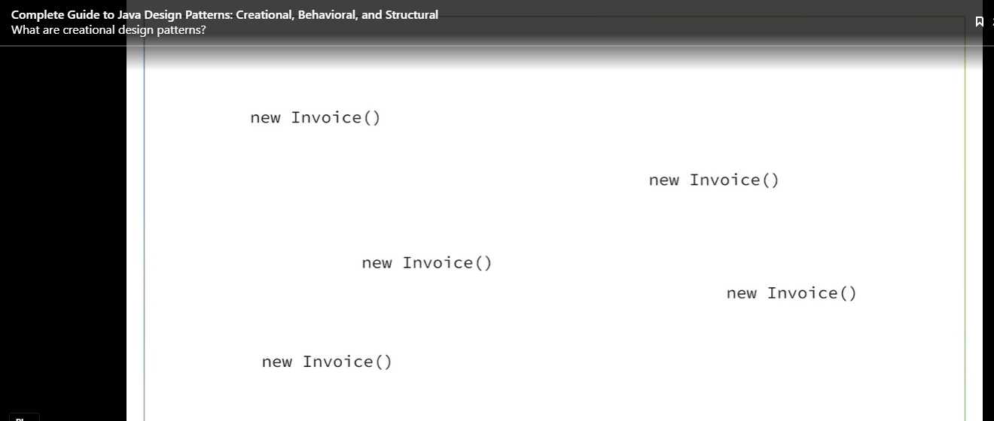

Our code is tightly coupled to the Invoice Class. This means I have to do change and test a lot of our code.

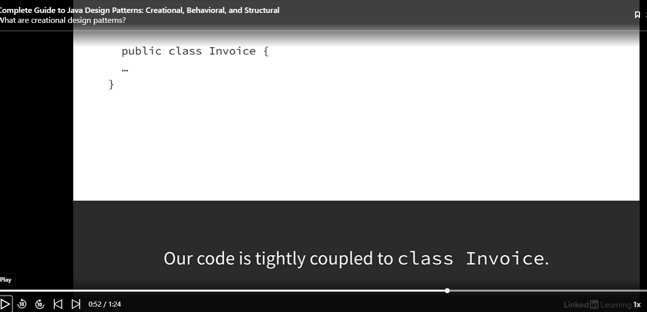

What do Creational Design Patterns do?

1. Encapsulates knowledge about which concreate class should be used.
2. Abstracts/conceals how objects are created.

### The Builder Pattern

#### Avoiding Complex Constructors

Problem: We want to avoid complex constructors.

A Person class is an example of a class that could have a lot of constructor parameters and would probably require a lot of constructor overriding, because many of these attributes could be optional Yuck!

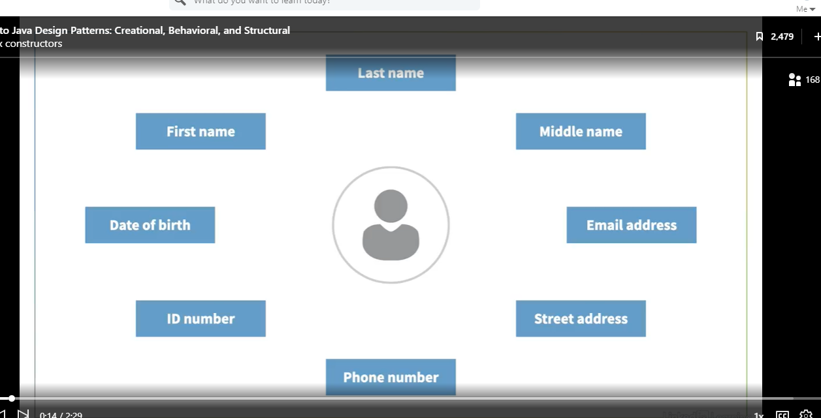

Now we often want to make our classes immutable in order to prevent bugs, but if this is true then we can’t change them later.

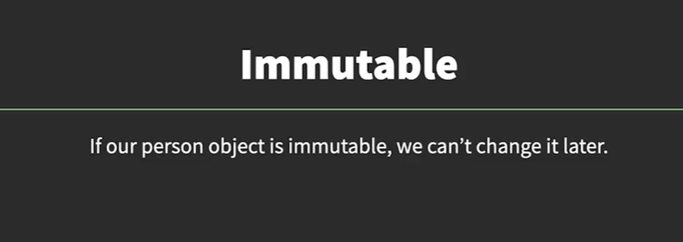

Yuck!

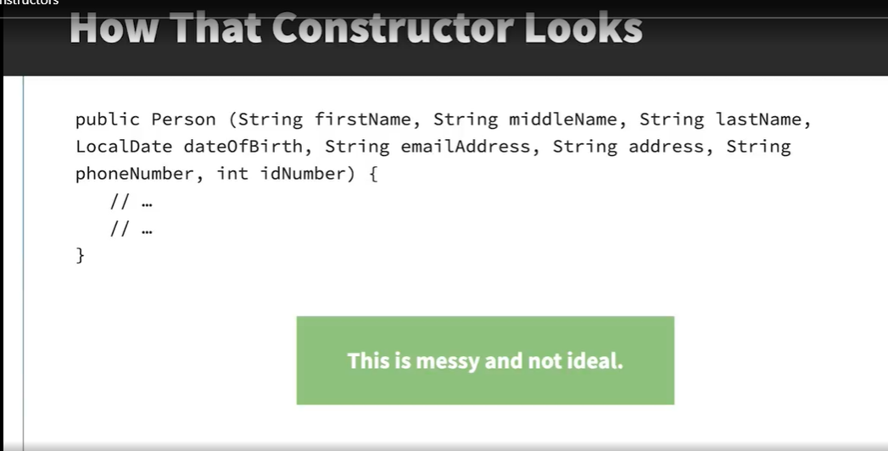

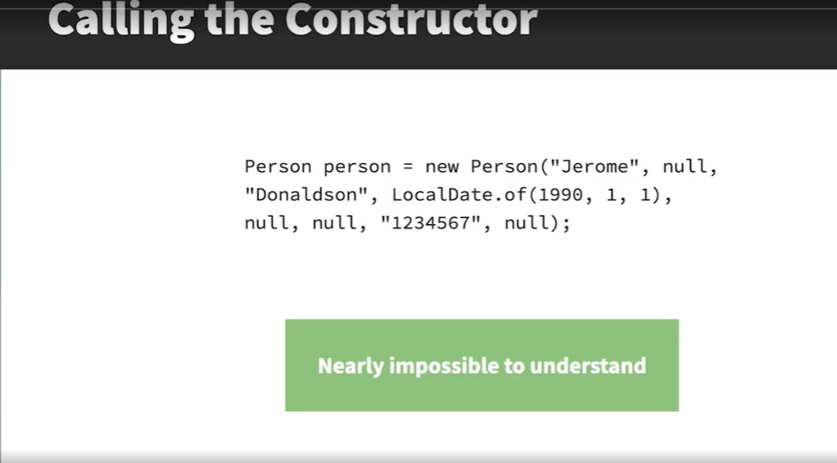

An alternative is to use overloaded constructors. Again Yuck!

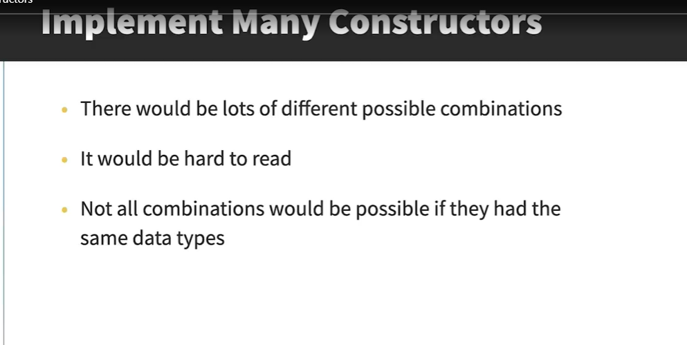

This is a job for the Builder Pattern.

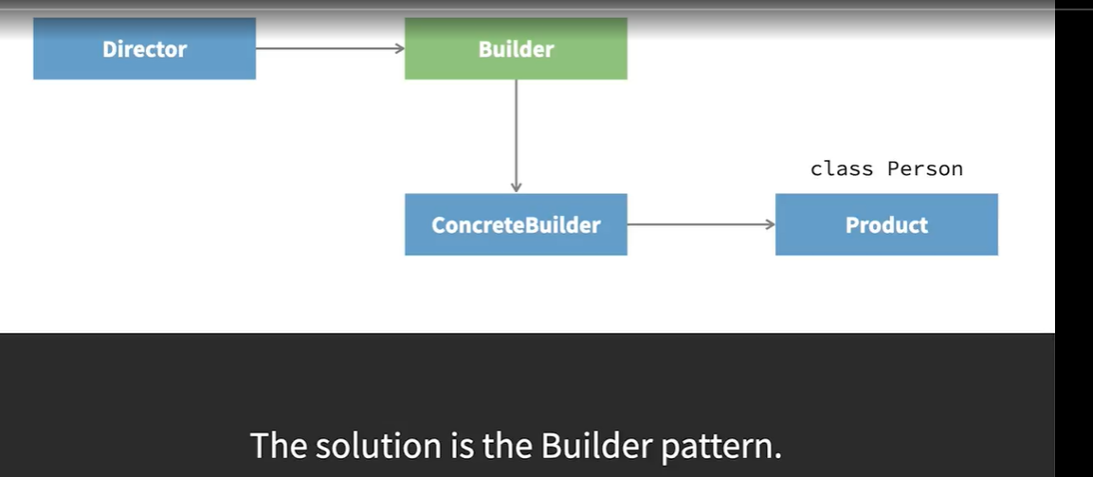

The solution to this problem is the builder pattern. In this pattern, you have a separate class that's used to construct the object using just the fields that you want, and this class is called the builder. In the traditional pattern, there's an interface for the builder and then a concrete implementation. The product is the class that would otherwise have the big constructor. So in this example, it would be the person class. And the director is the class that uses the builder to create the object. So, for example, the class where you'd be creating a new person object. In Java, is normally possible to simplify this pattern so you only have the concrete builder without the interface. So let's see how this looks with a real example in Java.

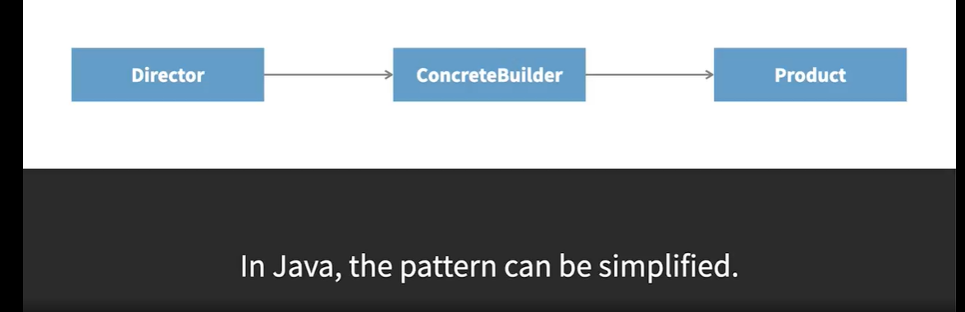

### Recognize where to use the pattern

See code below:

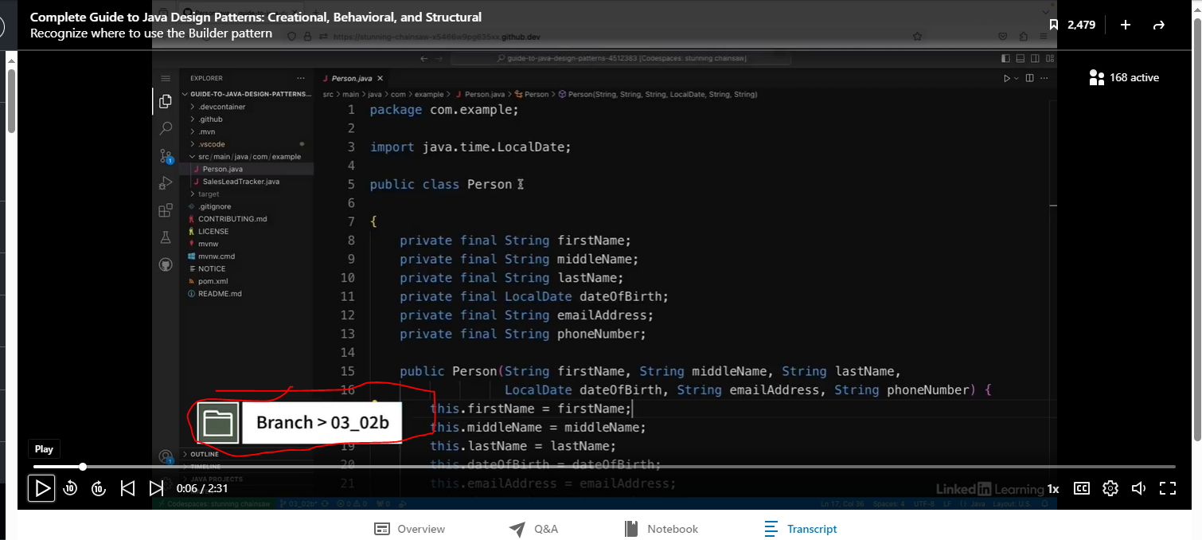

With this code, the first name and last name are required, and everything else is optional. Note there are a lot of parameters.

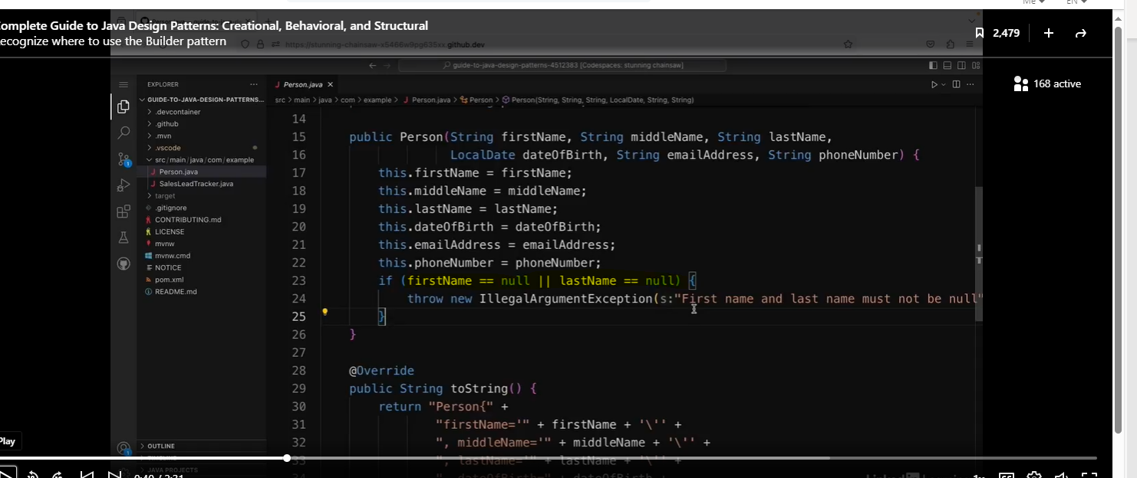

See code below. It shows how the Person object is used.

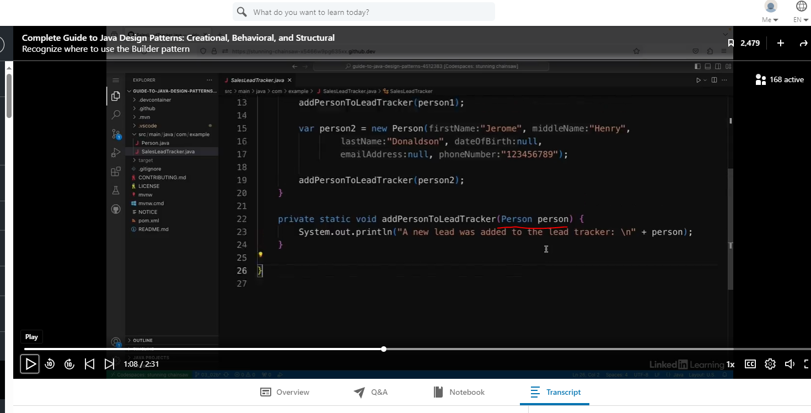

See person1 and person2 instantiation.

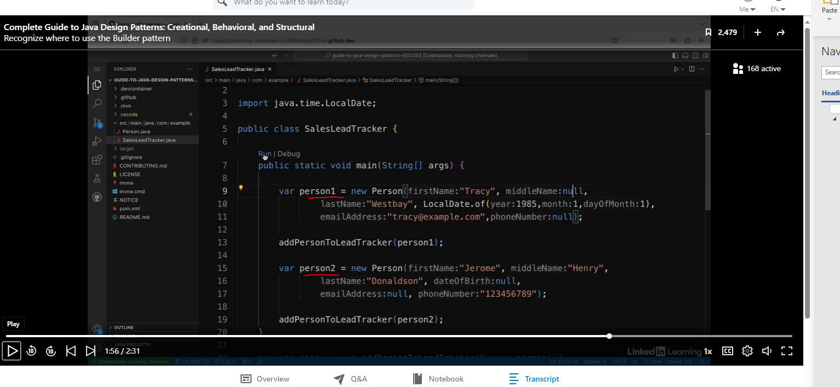

The code above does work, but it is hard to read and maintain.

### Implement the Complete Builder Pattern.

Inside the Person object, we are going to create a static class called PersonBuilder, which will reside inside the Person class.

#### Why are we creating a static class?

Making it a static nested class means that the builder class can't be used by itself. It can only be used when person objects are created.

We will first create the private field, and the Constructor will initialize the required fields. We will also remove the final keyword from the optional fields.

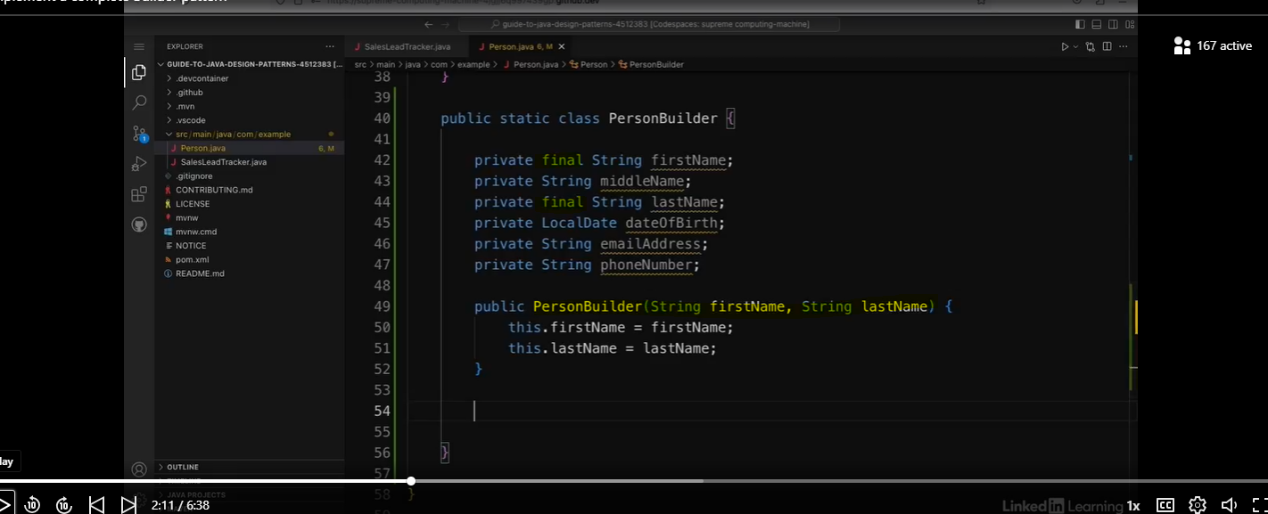

Now we will add a build method that will return a Person object.

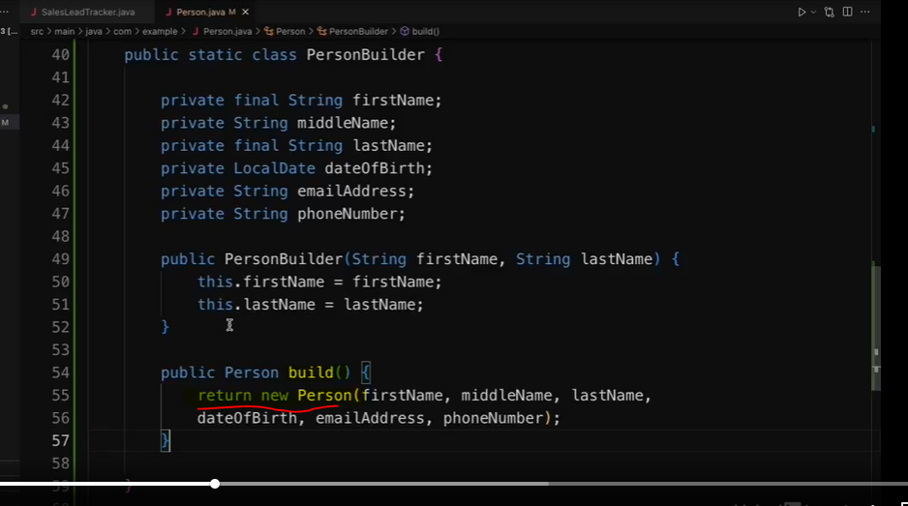

We will now create methods that will return a PersonBuilder object with the items of optional fields.

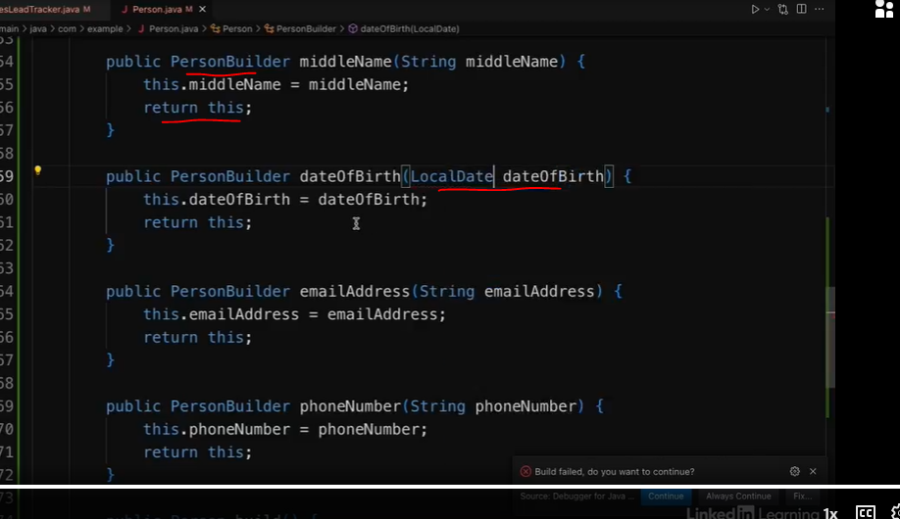

Instead of instantiating the Person object, we will use the PersonBuilder.

We will pass in the required fields, then chain methods for the optional fields, then finally call the build method.

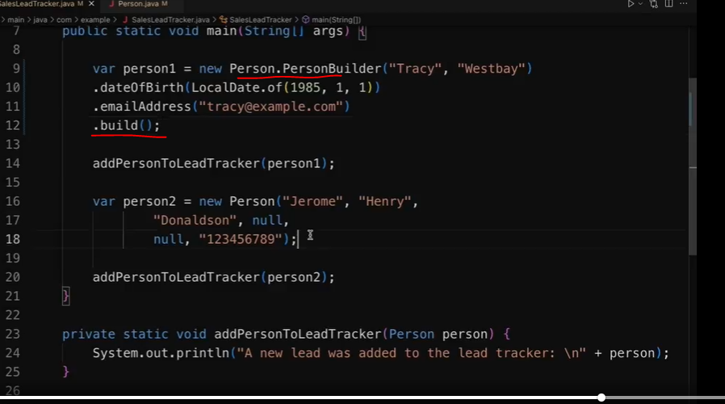

Note, how much easier this code is to read and maintain.

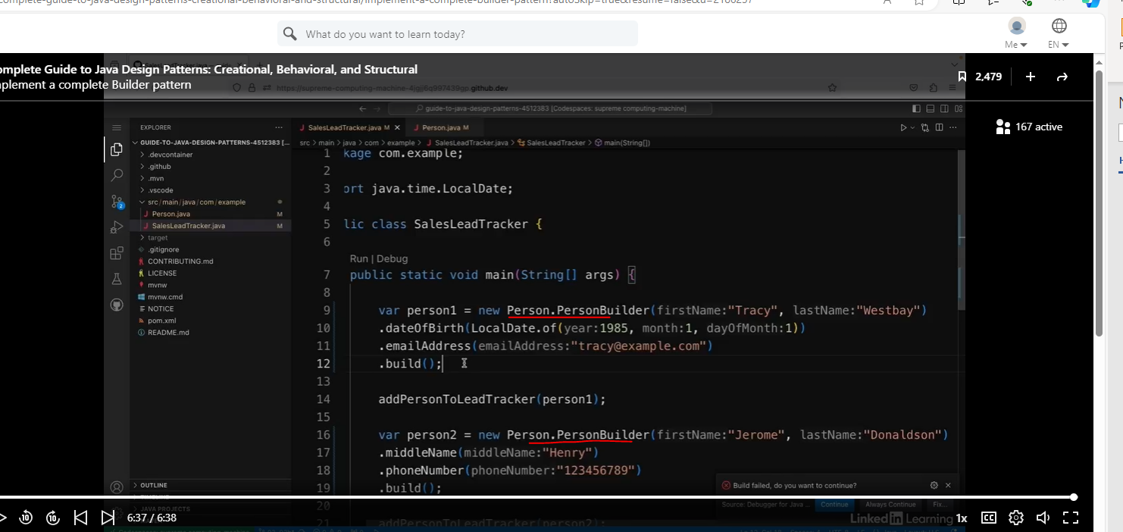

#### Improving the Builder Pattern

When we added the static class to the Person class, we did not modify the code, we actually just added the static nested class.

One problem with the code below is that the Public method is public, and that means the client can still use this.

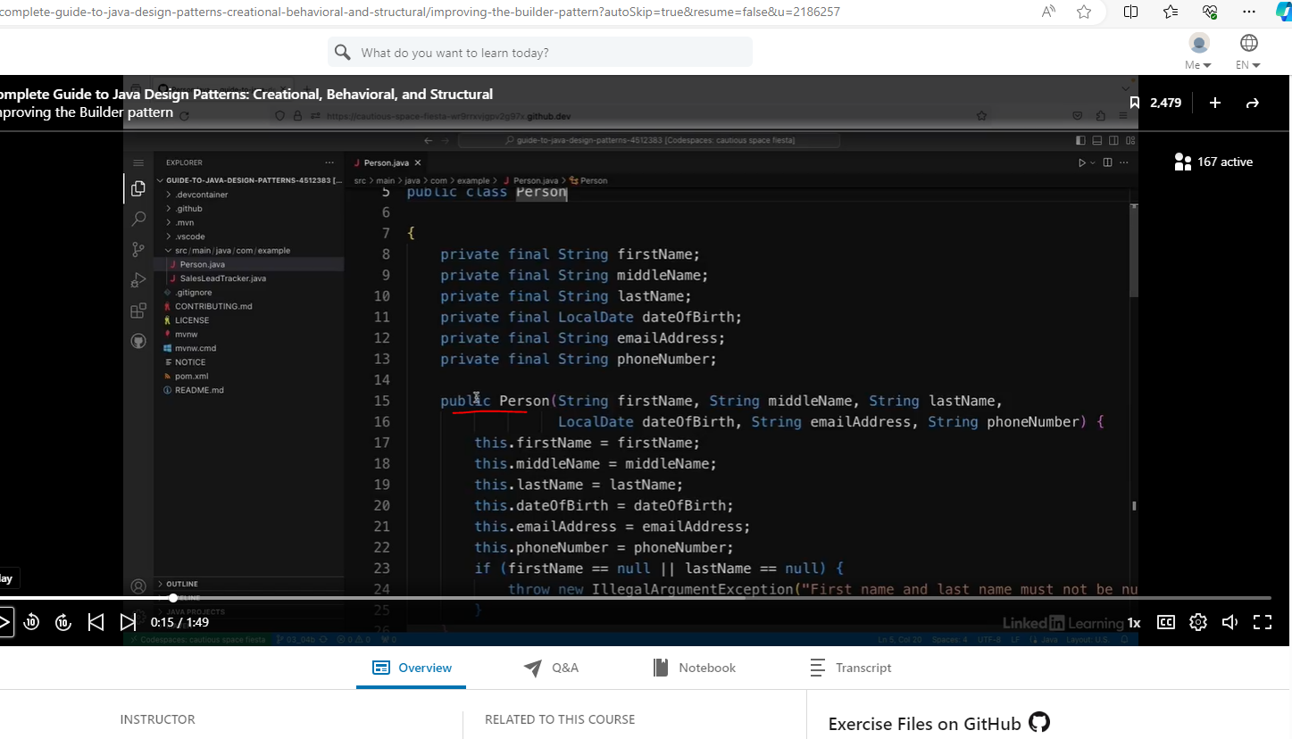

We are going to change the Person constructor to be private, and instead of passing in direct parameters, we are going to pass in the PersonBuilder object to the Person constructor.

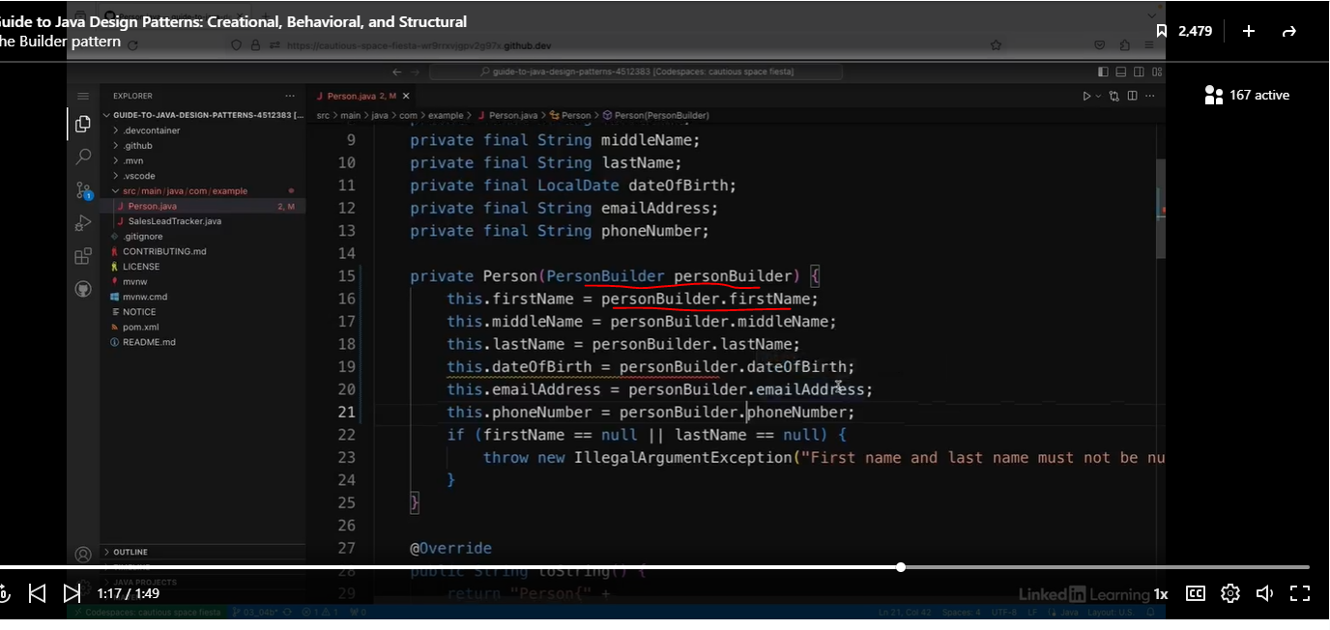

Note, the build method still has all of the parameters in the Person constructor:

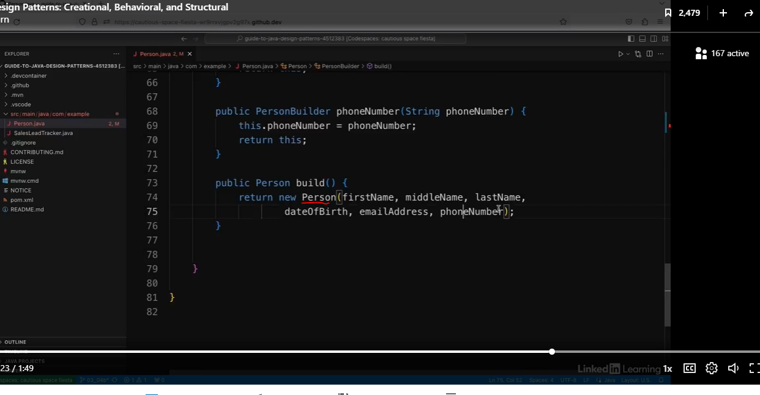

We will instead pass in the “this” keyword.

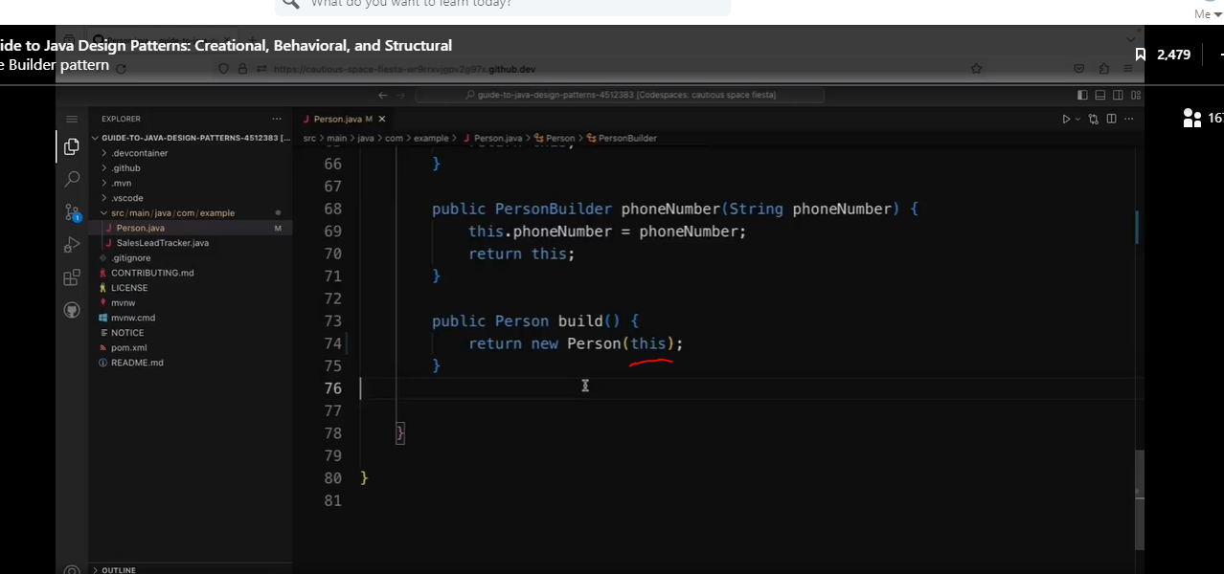

The nice thing about all of this is that we did not need to change the client code.

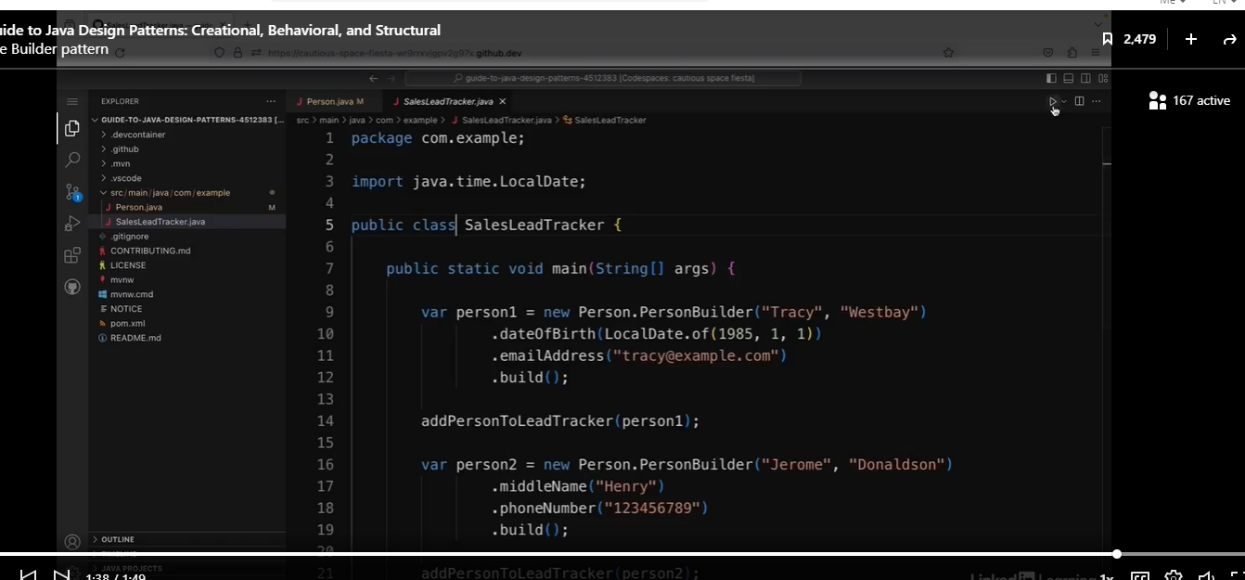

### The Singleton Pattern

#### When to use the Singleton Pattern?

Some would consider this to be an anti-pattern. We will discuss the pitfalls later.

This is the normal model, where we create multiple instances of a class (aka objects). We can create this all over our code base.

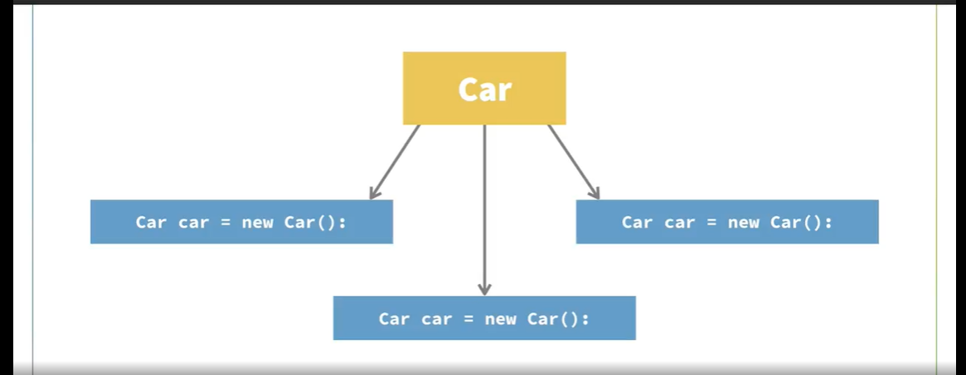

The singleton prevents this from happening.

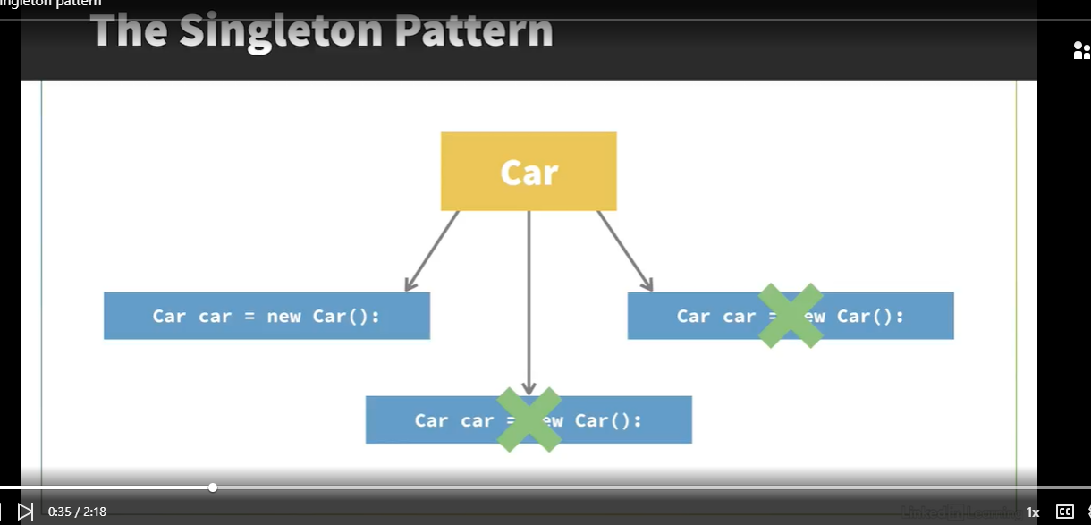

##### Why would we want to do this?

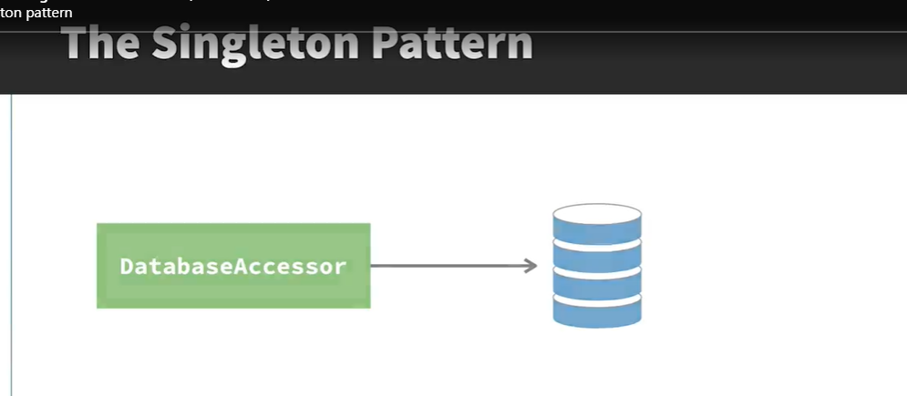

The next question is: Why would you want to do this? Say you have a resource that's shared across your application like a database. You might have a class that controls access to the database, and in that case, you would only want one object of that class. Otherwise, you could have a situation where multiple objects are trying to write to the same table using different instances of your DatabaseAccessor class.

##### Use Cases

* Connection to a database.
* Access to configuration files.
* Access to hardware resources.
* Loggers

##### Thread Safety

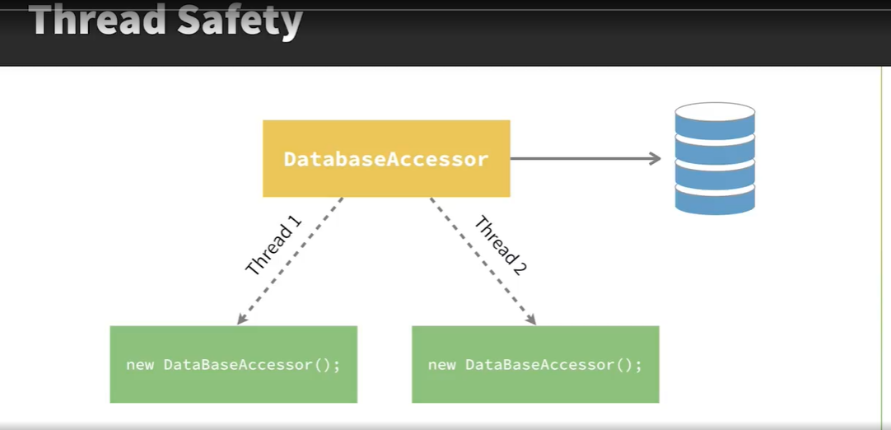

One of the things to consider when implementing this pattern is thread safety. If you have multiple threads in your application, each one could create a new instance of the singleton, which defeats the point. So this is something I'll show you how to handle later in this chapter.

##### Should use a Singleton Pattern?

Problem: Singleton pattern violates the Single Responsibility Principle (SRP).

In OO programming, a class should only do one thing. But with a singleton class, it does two things. It does whatever logic the class is supposed to do, for example, control access to a database, and it also ensures only one instance is created.

Problem: Singletons also are difficult to test.

Singletons also make your codes difficult to test, because the objects that use the singleton are tightly coupled to the singleton objects. So sometimes you can use other solutions, for example, dependency injection instead of using the singleton pattern. However, if you do have a use case where you want to have only one single instance of a class, the singleton pattern will allow you to do this.

### Implementing the Singleton Pattern

Let’s look at this simple code below:

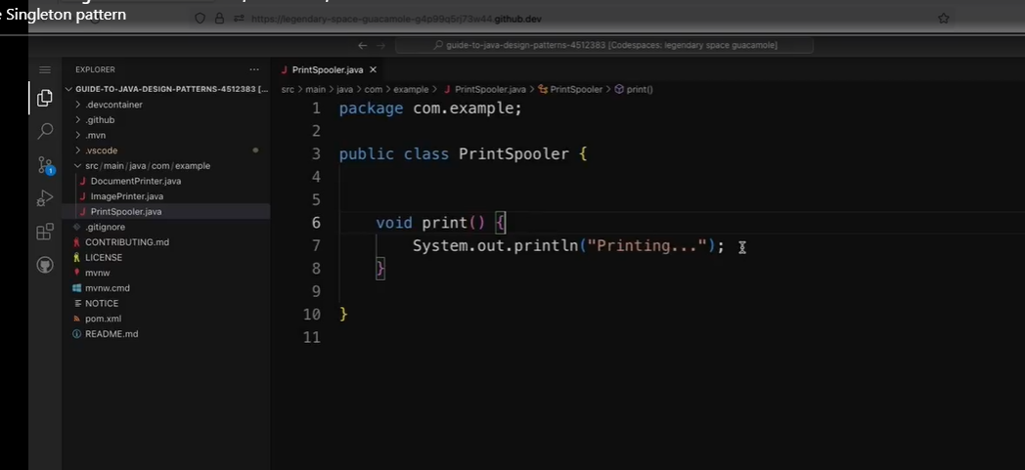

The PrintSpooler is used in two locations in the code. See examples below:

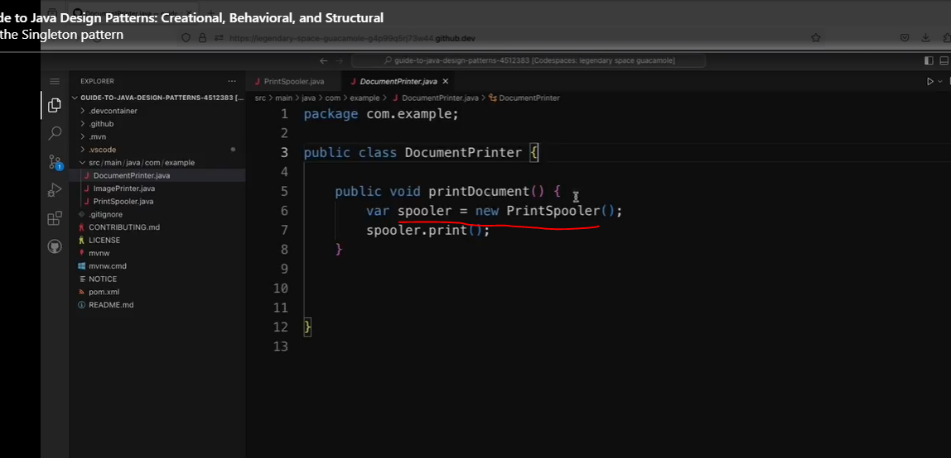

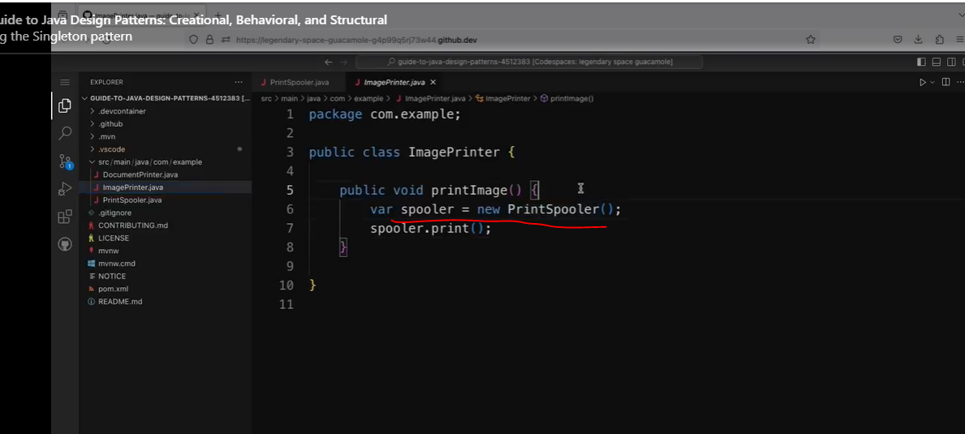

PrintSpooler object and then calls spooler.print. So I want to make it impossible to have this new PrintSpooler call, because I don't want the DocumentPrinter and the ImagePrinter both to create separate PrintSpooler objects.

First, we will change the class to a final class, so it cannot be extended, then we will add a private constructor.

So normally in Java if you don't have any constructor, it just creates a public one for you. So I explicitly need to create a private one. And this means that I won't be able to have any new PrintSpoolers anywhere else in the code. It can only be created from inside this class itself.

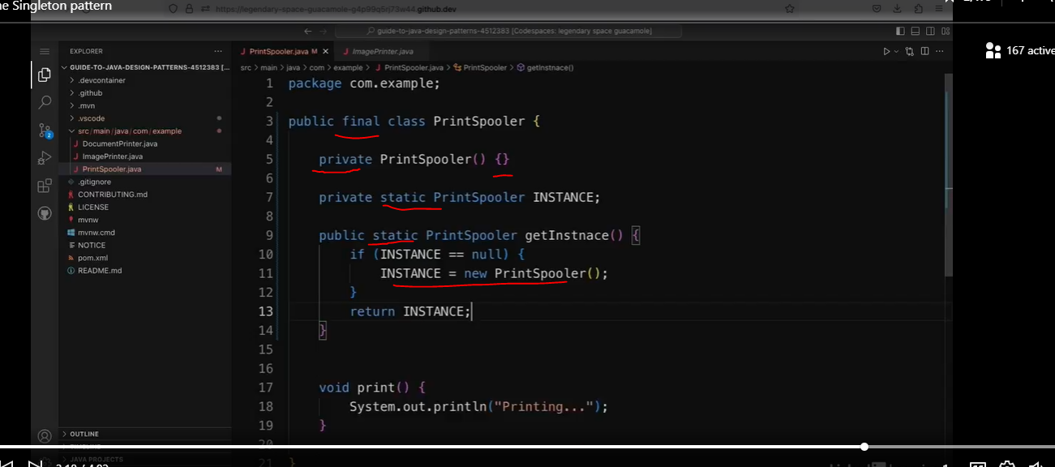

So I still need a way to create the one single instance that's going to be used, which is going to be done inside this class. So underneath my constructor, I'm going to create a field and it's going to be a private static field. And it's going to be static because I only want one instance to be created. And it's going to be a PrintSpooler object and I'm going to call it "INSTANCE." And because it's static, I'm going to put it all in capitals. So now I need a way to access this instance. So I'm going to create a new method underneath this field. And it's going to be a public method. And it's going to be a static method. So static methods are methods that belong to the class, which means you can call them without creating instances of the class, which is essential for me here, because I won't be able to create new instances of this class. So it's going to be a public static method, which is going to return the PrintSpooler INSTANCE, and I'm going to call the method getInstance.

Now let’s update our client code.

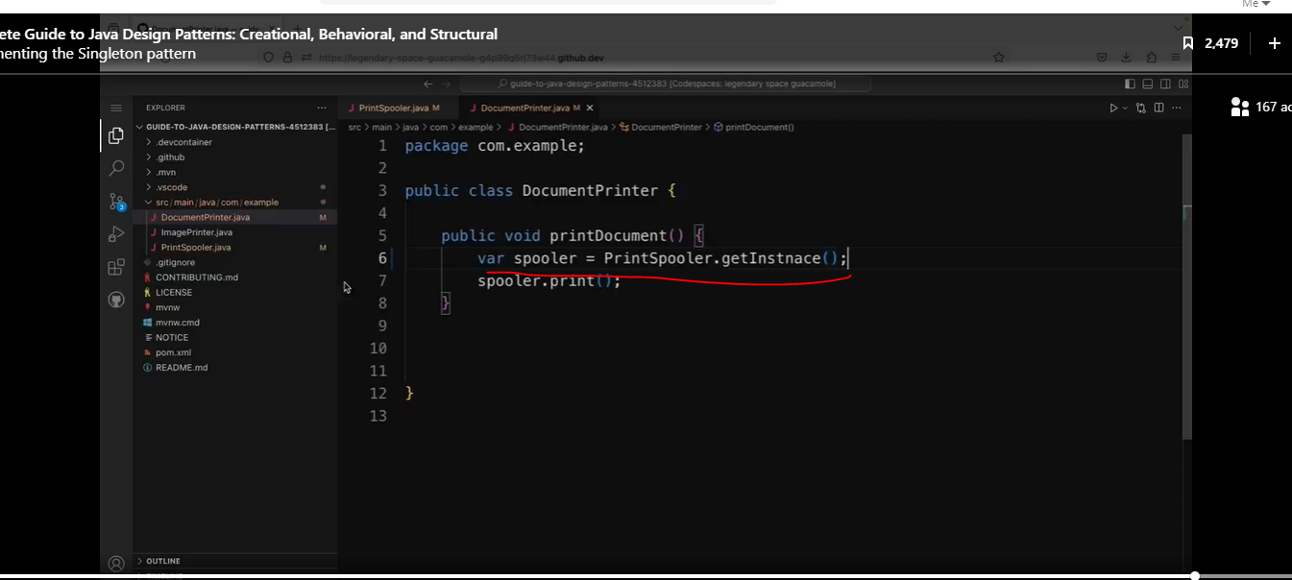

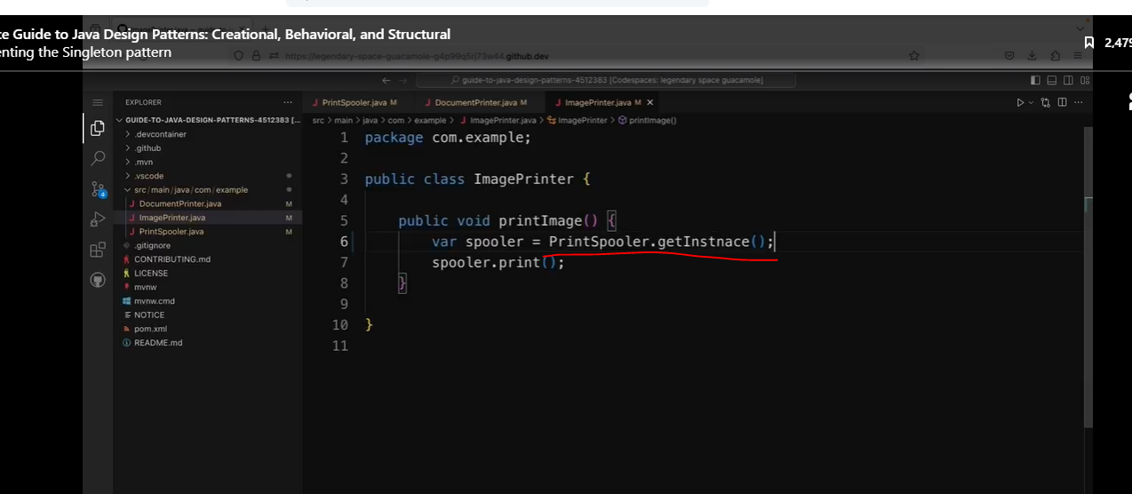

### Thread Safety with the Singleton Pattern

See the code below:

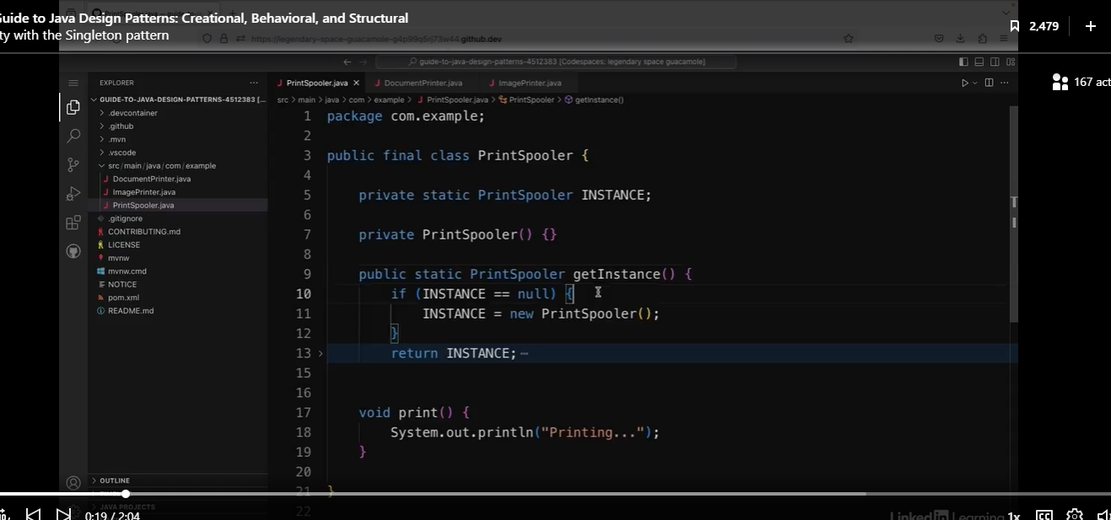

A common pitfall when implementing the singleton pattern is not making the solution thread-safe. So, for example, in this PrintSpooler class, you can imagine a scenario where two threads are using this application, and they both call this getInstance method at the same time. And then they both check if INSTANCE is equal to null at the same time. And now the thread has actually created this new PrintSpooler yet. So in both cases, this is true. So they both come in here and they both create a new PrintSpooler objects. So then I've ended up with two PrintSpoolers when I should only ever be able to create one.

Now we can make the getInstance method synchronized, but this could slow performance if this method gets called a lot.

Check out the solution below. It uses an ENUM.

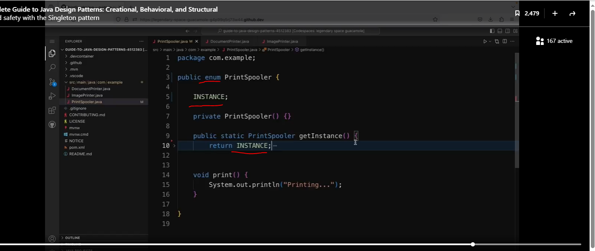

Why does an ENUM work? Because ENUMS are guaranteed to be thread safe. Not only did we not need the synchronized keyword, but we were actually able to simplify our code.

The nice thing is that enums in Java are guaranteed to always be thread-safe. So this is a nice way of making sure it definitely works as I intended without having to implement that thread-safe guarantee myself. And it's actually a simpler solution to the one I had before with less code. One thing to note is that you wouldn't be able to use this approach if the singleton class has to implement a superclass, for example. But otherwise, this is probably the better approach for implementing the singleton pattern.

### Note to Self

I have to check my notes, but I think we would utilize this if we have a lot of functional programming, because I think functional programming does not really work with accessing to external resources, because external resources will not always produce consistent results like Functional Programming is designed to do.

## The Prototype Pattern

### Understand the Prototype Pattern

#### Lost of similar objects are created



Imagine a scenario where you have to create lots of very similar objects. As an example, say you're creating a user interface which displays a forest of trees. To create the display, you'd need to create lots of Tree objects. For example, say you need to create 50 fir trees, 50 oak trees, and 50 silver birch trees to create the scene. Let's think about how this might look when it's implemented in code.

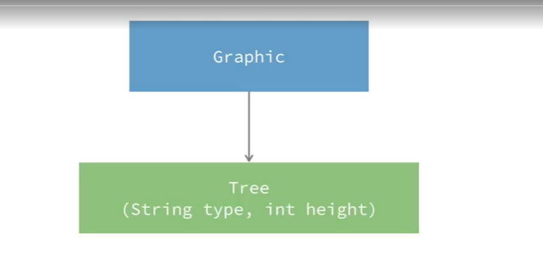

##### WOW! That is a lot of new tree variables.

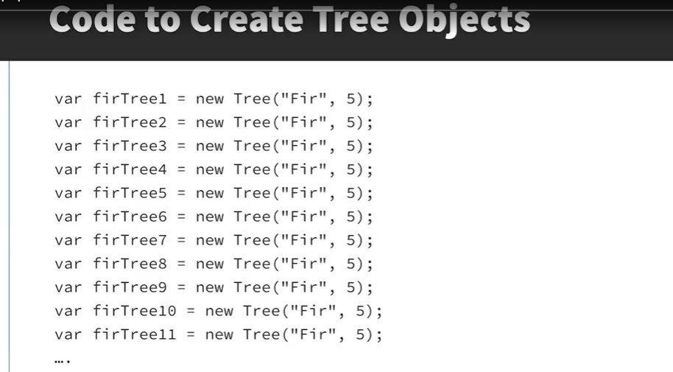

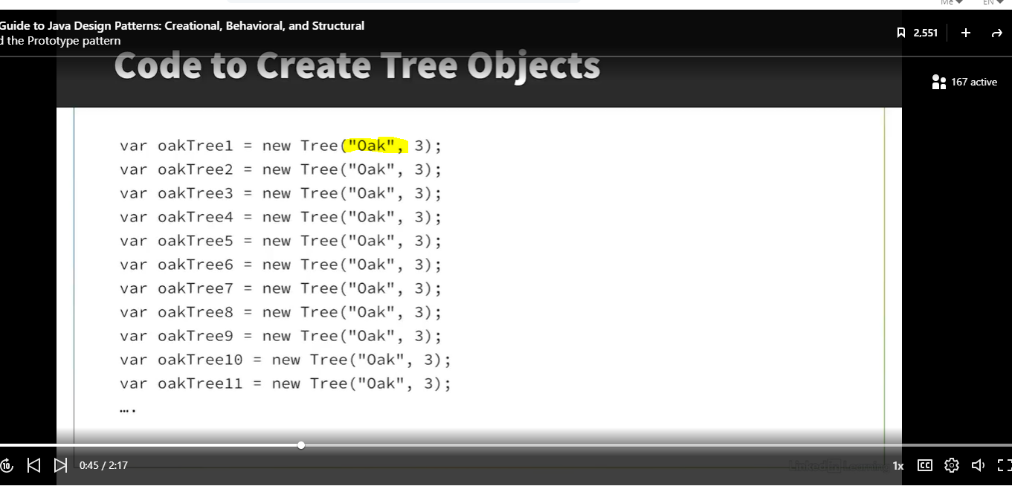

#### Solution

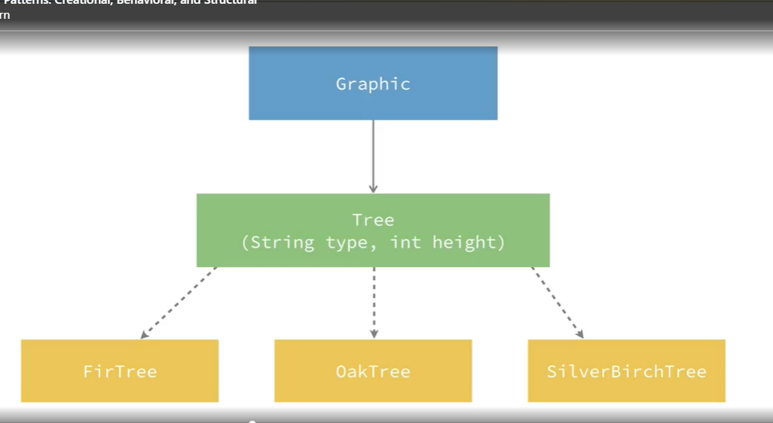

However, one drawback to this is that it makes the hierarchy more complex, especially if I start adding new types of trees later.

#### Better Solution: Prototype Pattern

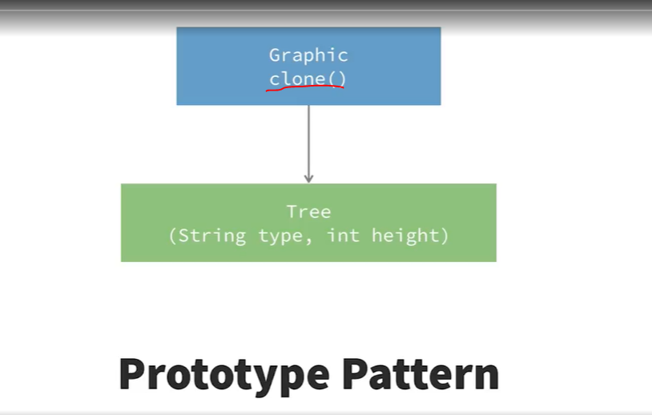

So the other option is to use the prototype pattern. With this pattern, the interface at the top of the hierarchy defines a clone method, and then the Tree class also has a clone method. This clone method means that we can copy the configuration of an existing objects without having to complicate the class hierarchy. Think of Dolly, the sheep that was cloned. The prototype pattern essentially does this for Java objects, so that similar objects don't have to be configured multiple times. One thing to note is that there is an interface called Cloneable in Java.



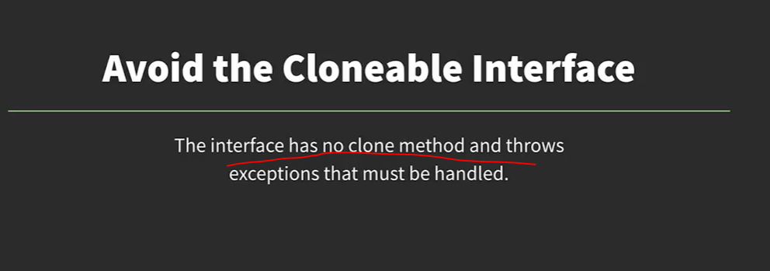

One way to implement this pattern is to use this Cloneable interface. However, there are some issues with this interface that is worth knowing about. Firstly, it has no clone method, so using it doesn't really tell us much about what the implementing class is going to do, and it's also a bit of a hassle to implement. We have to implement the interface and handle the exception it throws without any real benefits. So for these reasons, the Cloneable interface is often avoided in Java. In my examples, I'm going to be using an approach called the copy constructor, which is a bit simpler to implement.

### Implement the Prototype Pattern

See class below called Meal. It is an abstract class.

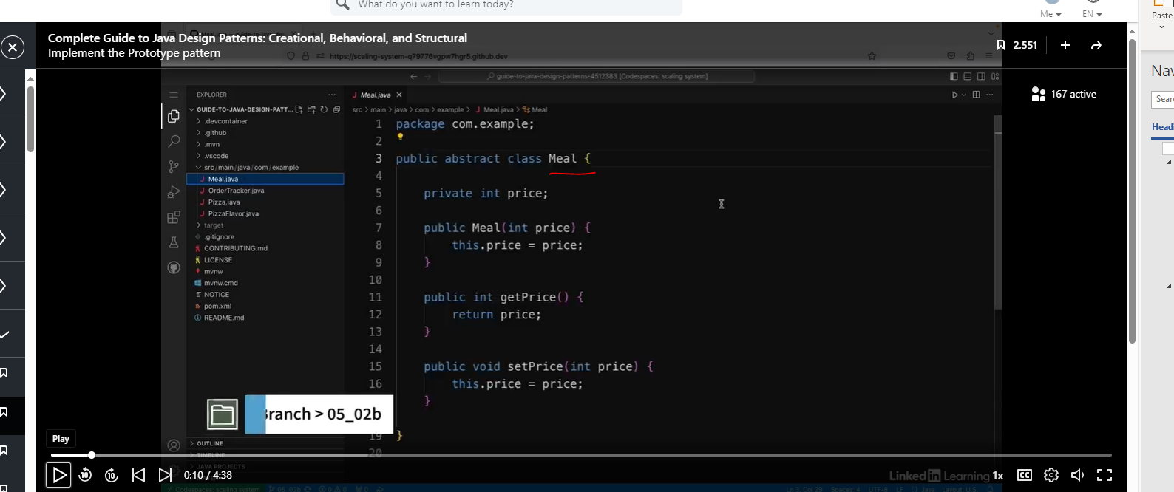

Let’s look at the Pizza method.

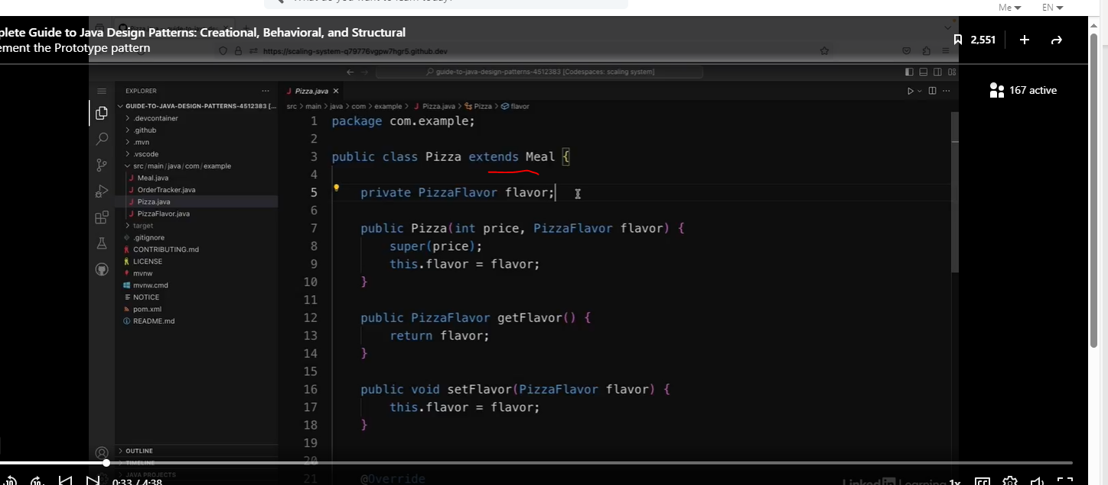

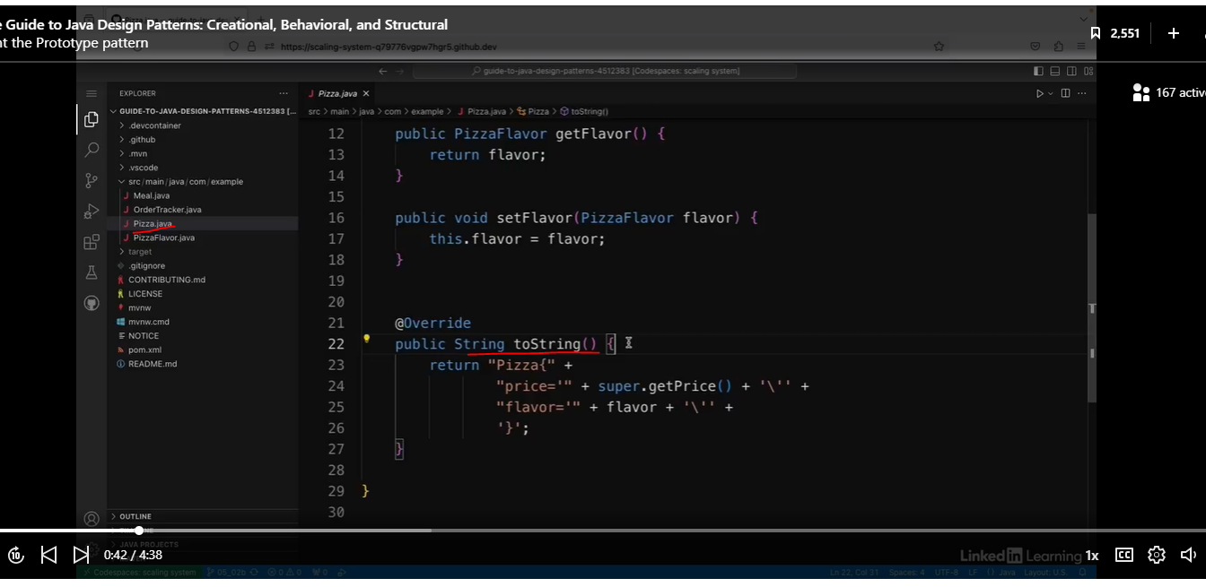

Let’s look at the Pizza Flavor method.

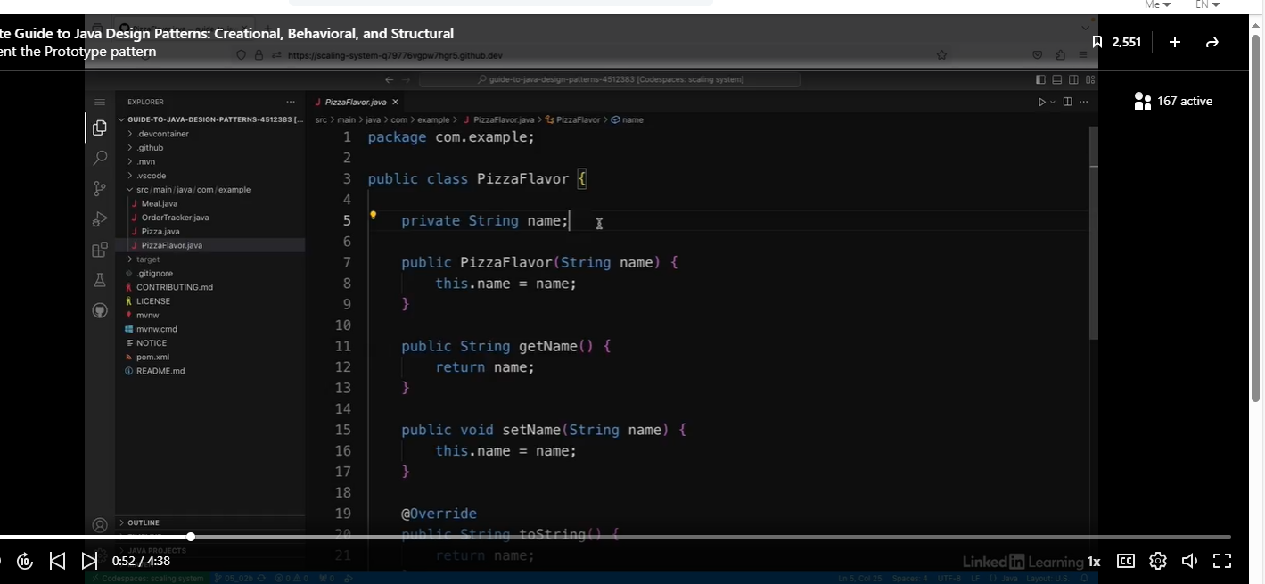

Let’s look at the OrderTracker class that uses both the Pizza and PizzaFlavor class.

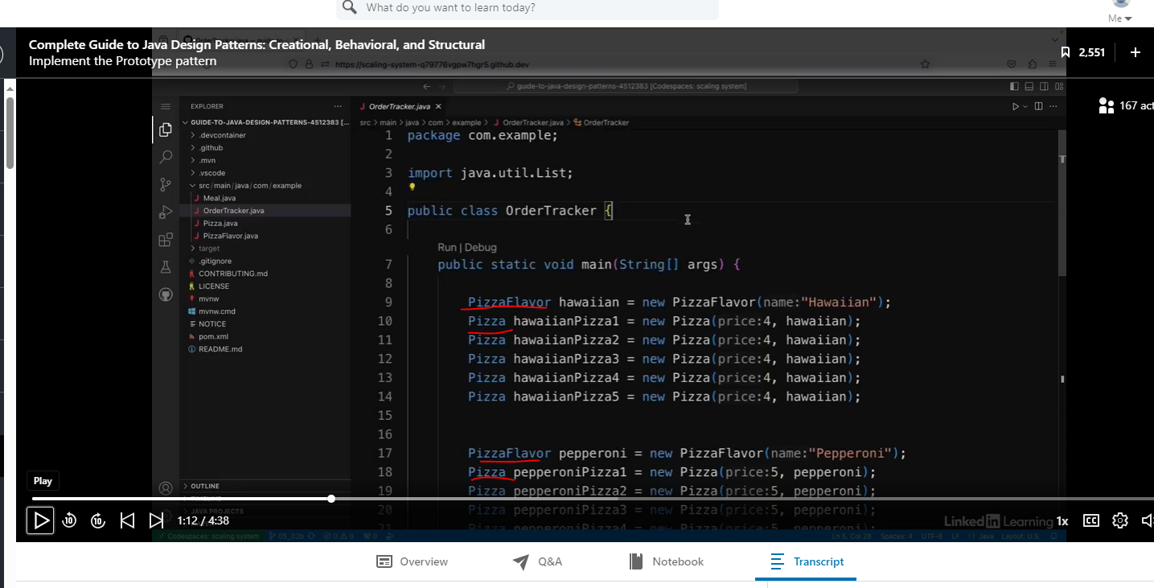

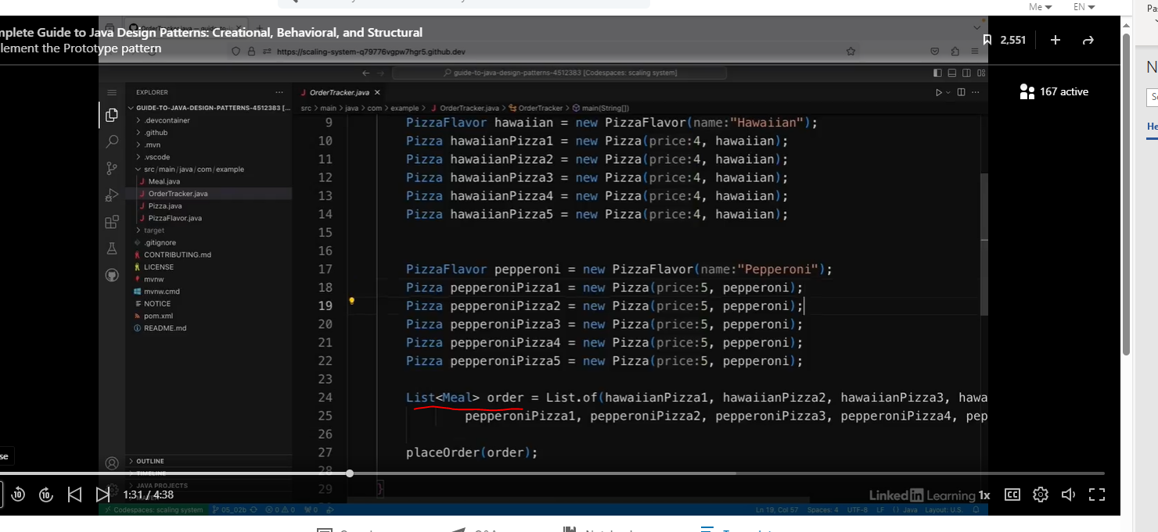

If you look at the code above, then you will notice there is a lot of duplicate code. As you know this is very, very bad.

#### The clone method

Let’s refactor the Meal abstract class.

Let’s add a new abstract class called “clone”.

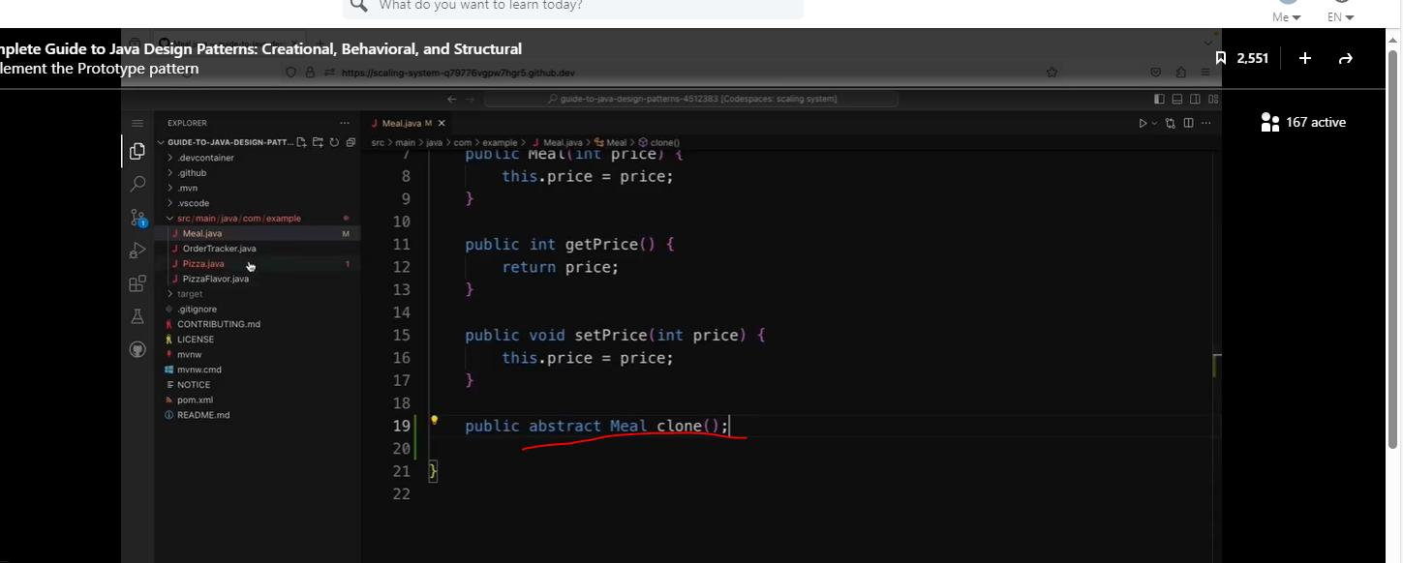

We will need to implement the clone class in the Pizza class.

Check out the code below.

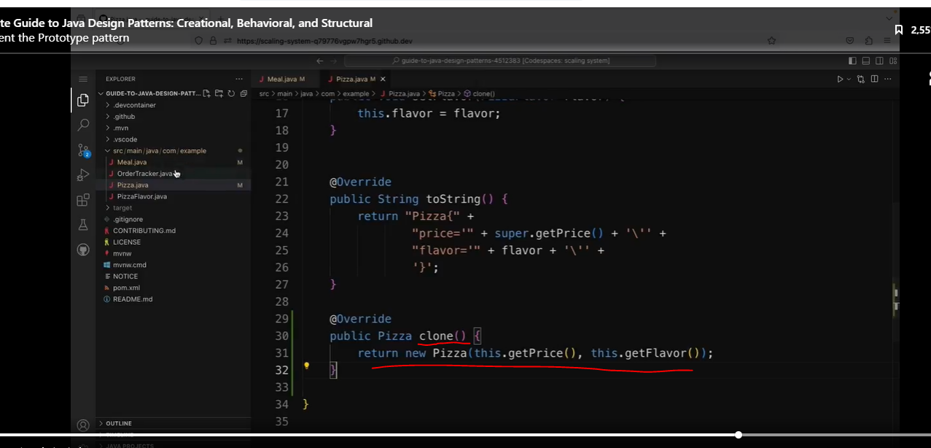

Instead of explicitly creating new objects with the constructor, we call the .clone method in the hawaiianPizza object. We will also do this to the peperoni pizza class eventually, but I wanted to show you the differences.

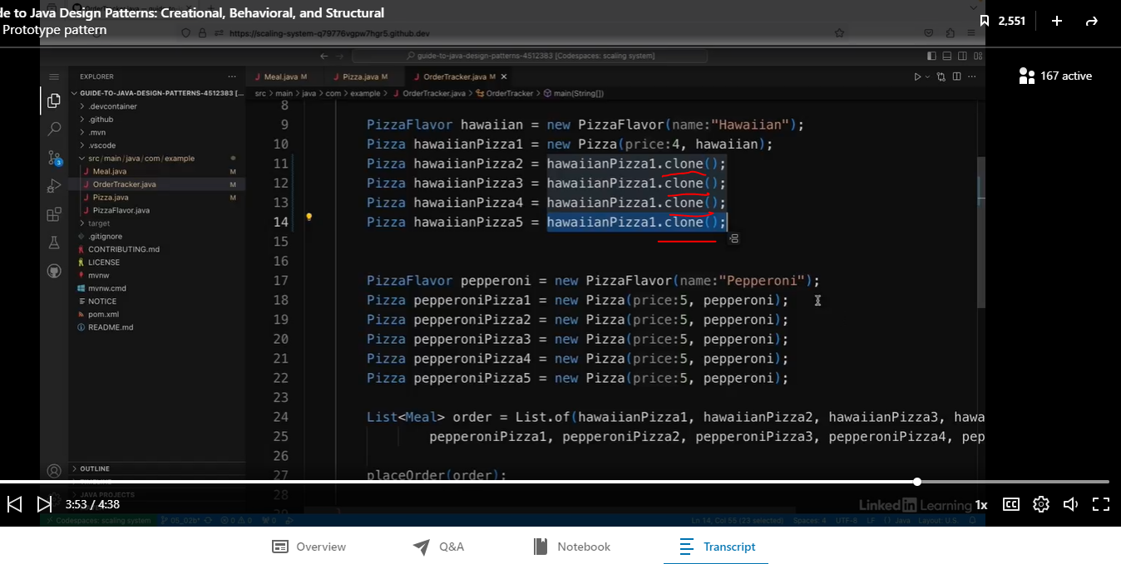

Now the code works as expected.

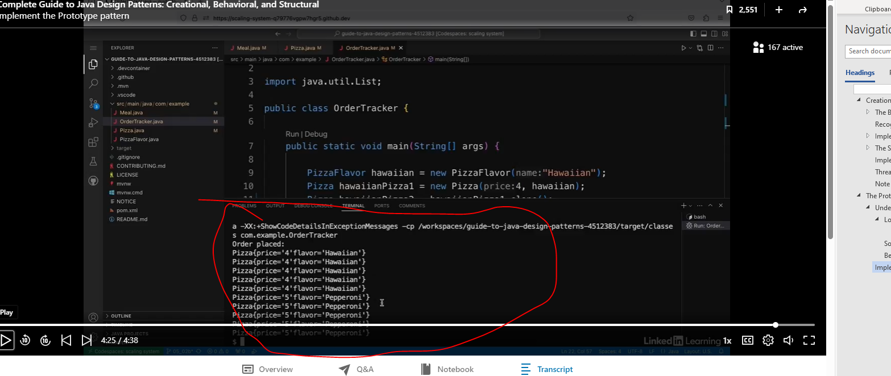

### Handling Mutability

Let’s begin with the OrderTracker method.

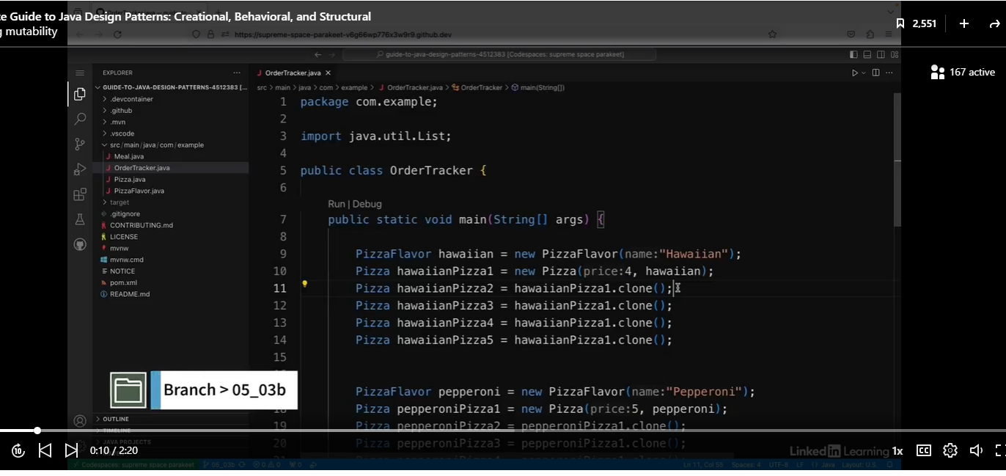

Let’s try adding the code below:

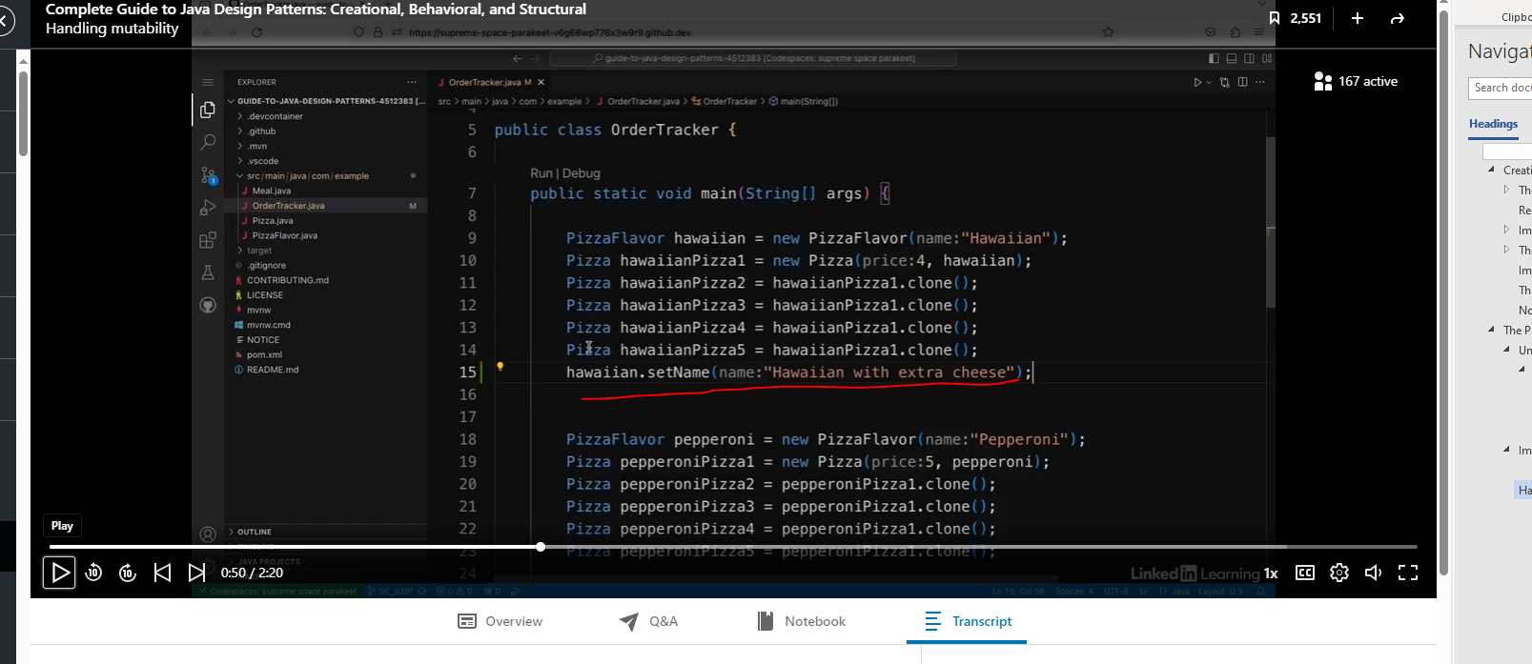

When you do this, then the changes will be applied to all Hawaiian Pizzas.

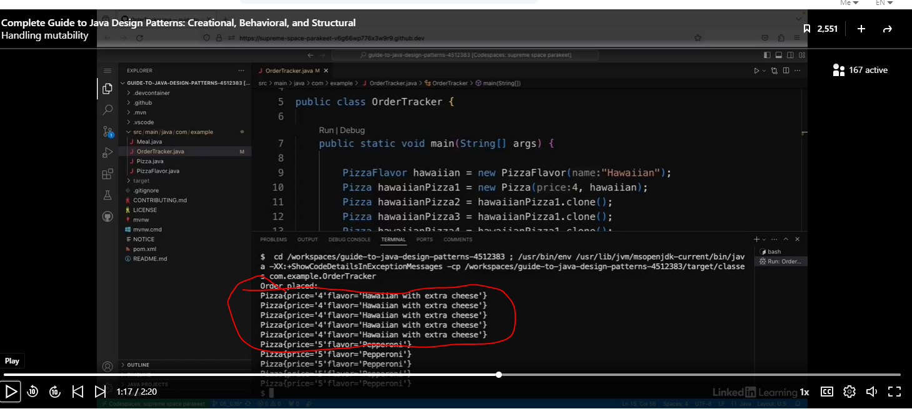

To fix this, we are going to need to fix the clone method in the Pizza object.

We are changing the pizza and the pizzaFlavor classes.

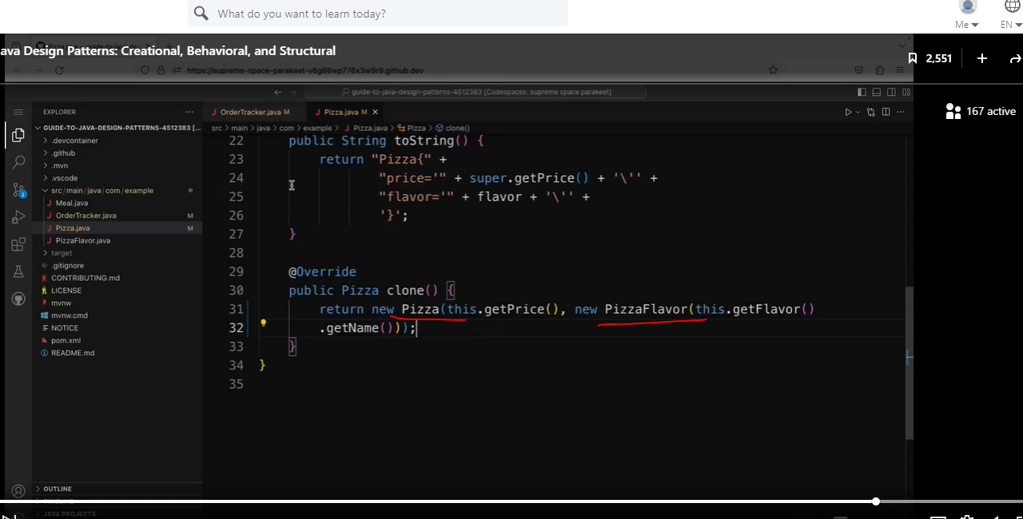

When we run the OrderTracker code, then only one object will change instead of all of them.

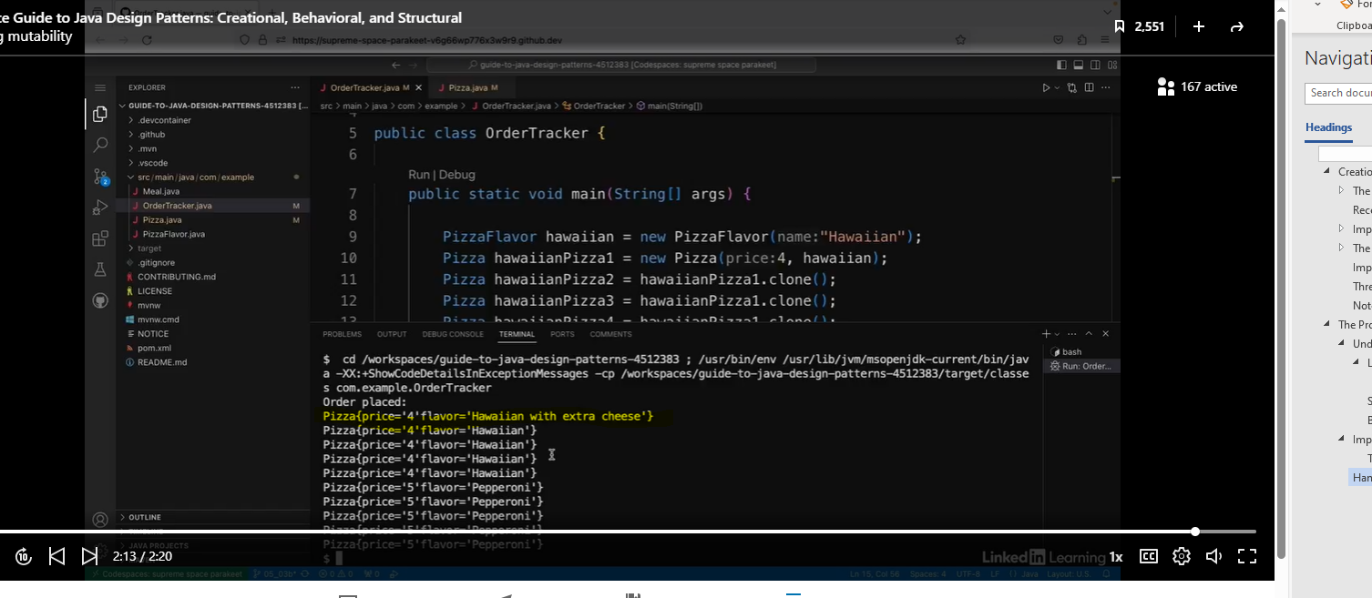

So now if I go back to the OrderTracker and I run this again, I can see that this time the flavor has only updated for the first pizza, and the clone ones still have the original flavor. This is because the flavor field is now a separate object, so it can't be changed by accident any longer.

### The Factory Method

#### Understand the Factory Method Pattern

##### Analogy: The Ticketing Machine Application

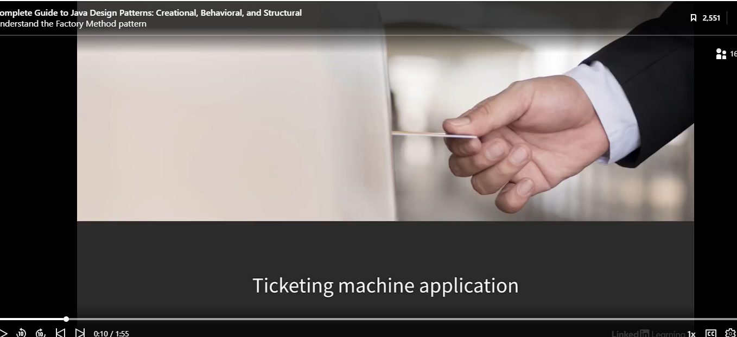

In the beginning, the ticket machine crates bus tickets.



What if we want to also create train tickets?

The TicketMachine class creates Ticket objects. So far so good. But later, I might want to have ticket machines that sell different types of tickets, for example, train tickets. So in my code, I might introduce a ticket interface with two concrete implementations called bus ticket and train tickets. The problem is that the TicketMachine class doesn't know in advance which type of ticket it needs to create; bus tickets or train tickets. This is the problem that the factory method pattern solves.

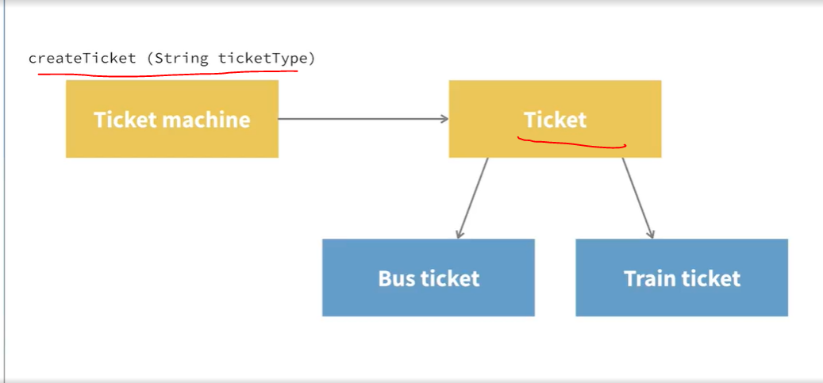

###### Bus tickets or train tickets.

This is the problem that the factory method pattern solves. There are a couple of different variations of this pattern. One variation is to have a factory method inside the creator. So in this case, the TicketMachine would have a createTicket methods that can return different types of tickets. So in this createTicket method, you would pass in a parameter that would be either bus or train, and then it would return the correct concrete type based on that parameter.

###### Alternative

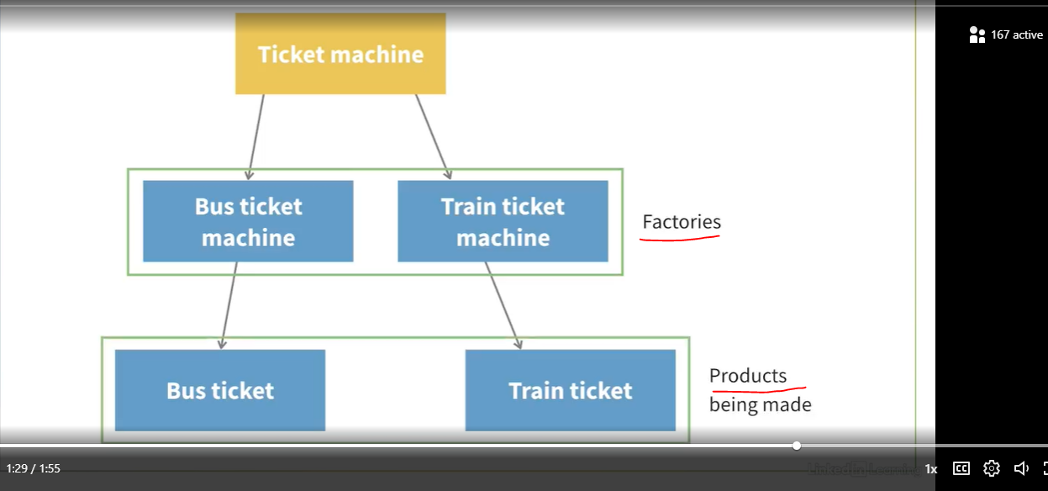

he alternative is to create different types of ticket machine that are responsible for creating different types of tickets. So bus ticket machines could create bus tickets and train ticket machines could create train tickets.

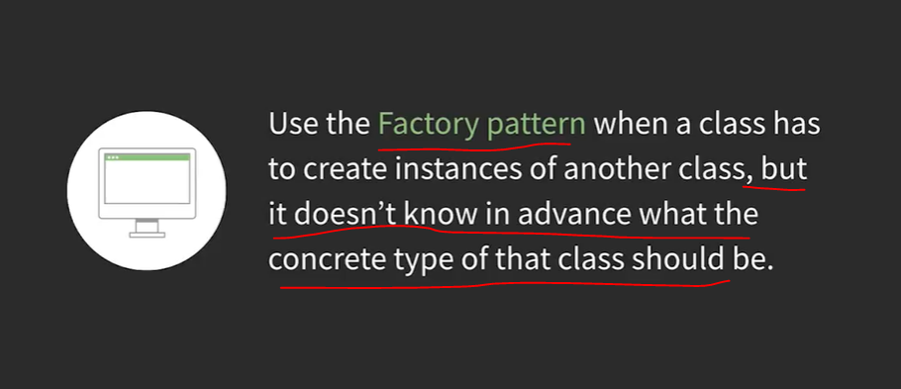

So to summarize, you use the factory method pattern when you have a class that's responsible for creating objects of another type of class, but that class doesn't know in advance which concrete types of the class it should create.

A nice side effect of this pattern is that the creation of the object is encapsulated in one place, so if it changes, the call to new is only in that one place and only needs to be changed there.

#### Implement the Factory Method

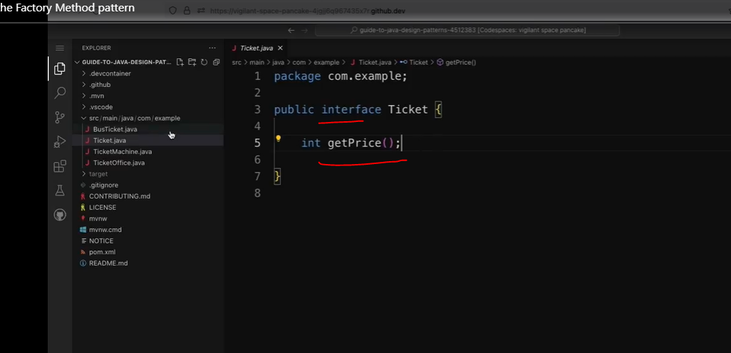

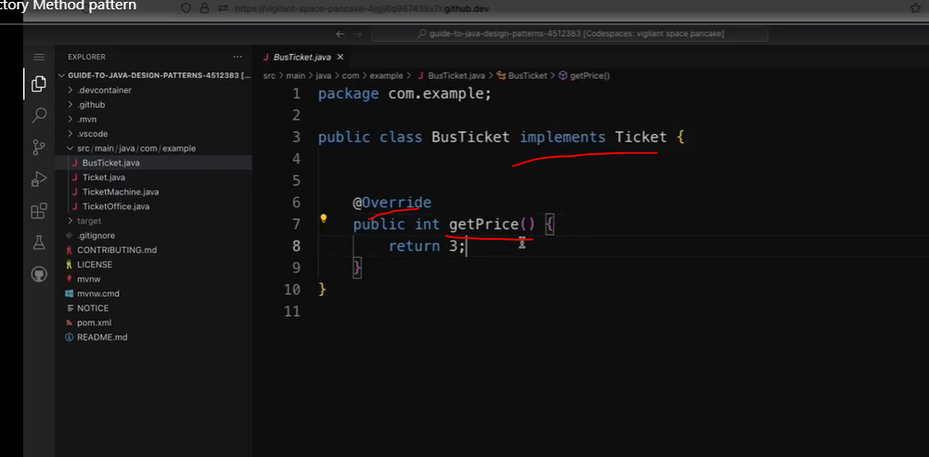

See Ticket Machine.

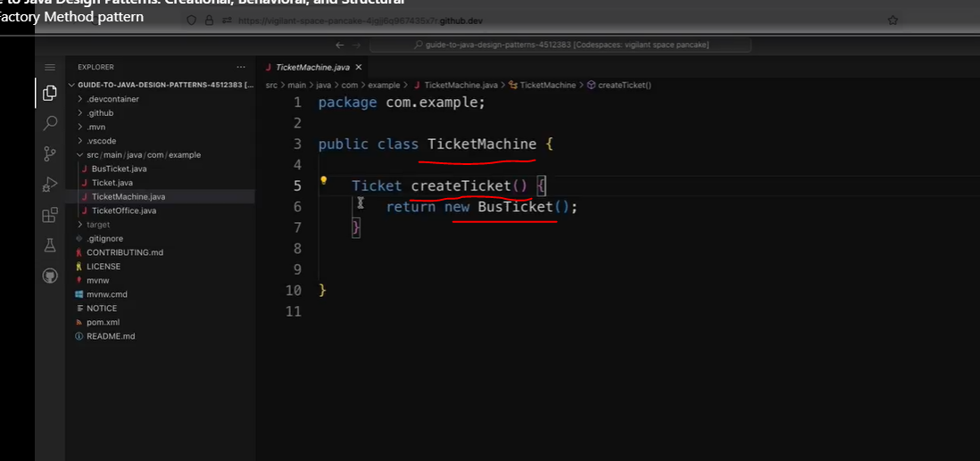

Check out the TicketOffice class below:

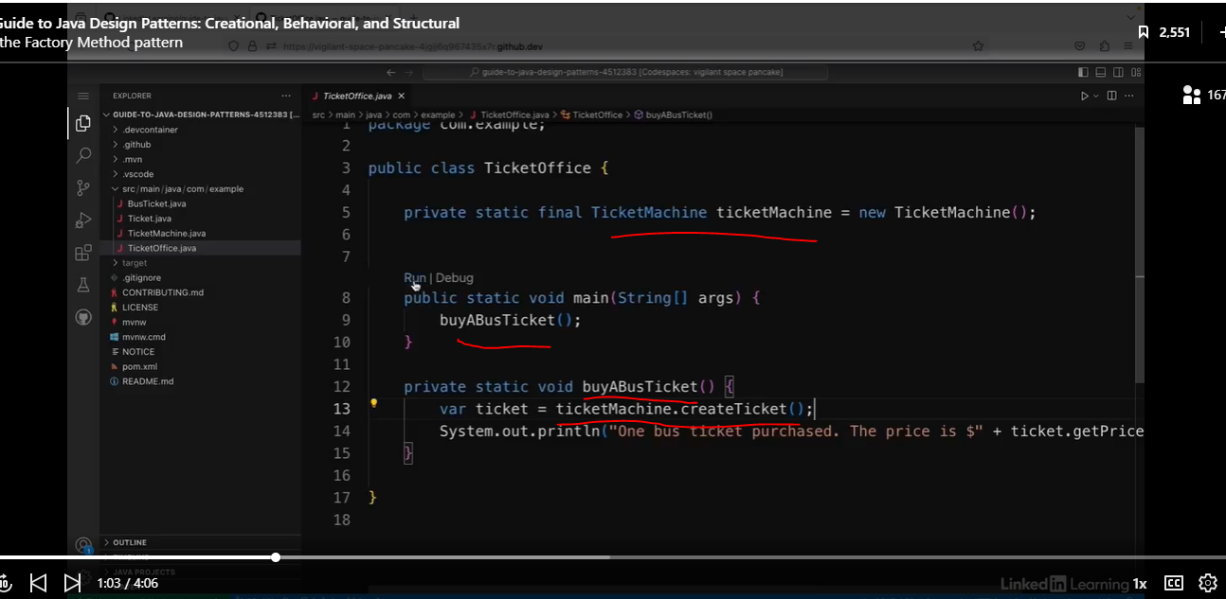

Can I buy train tickets from the office above?

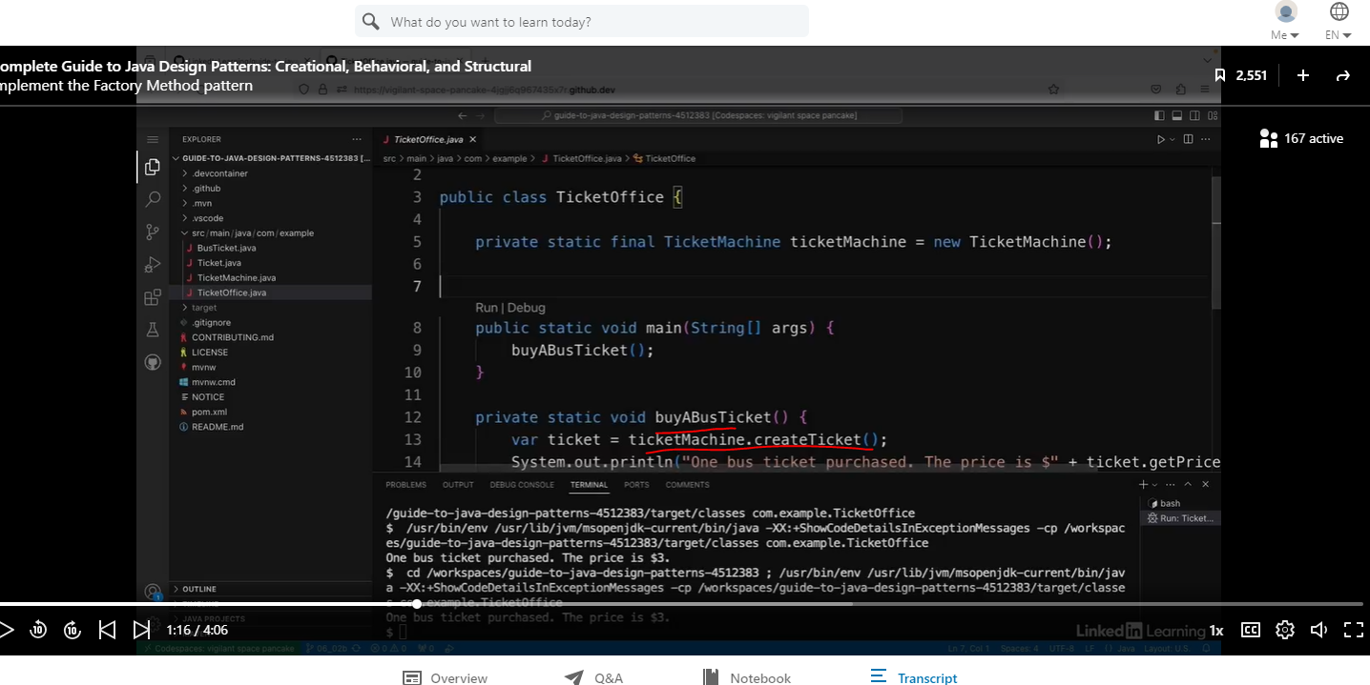

Let’s create the TrainTicket class.

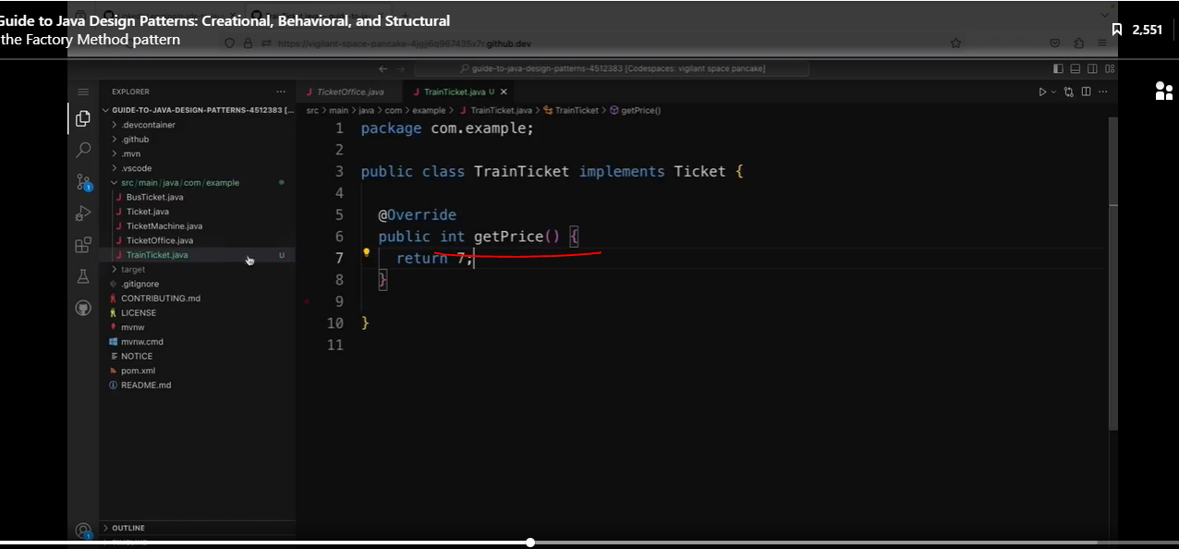

So now the ticket machine has to be able to return either a bus ticket or a train ticket. But it doesn't know in advance which one it should return. So I'm going to make this createTicket method into a factory methods.

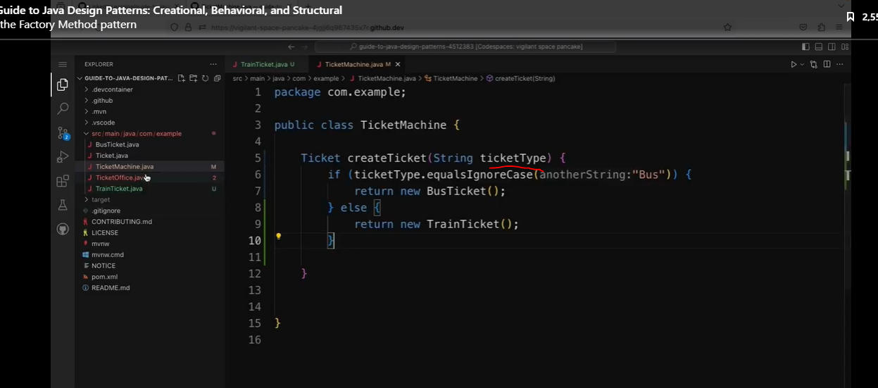

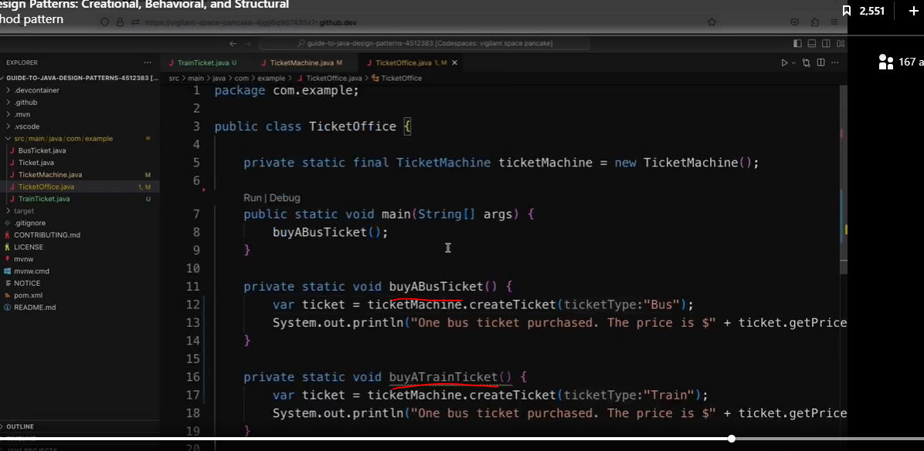

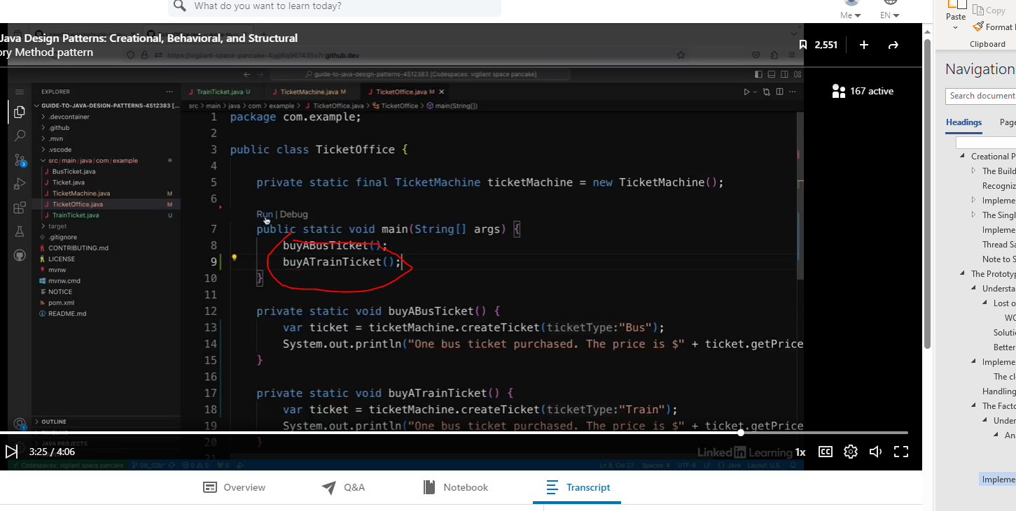

Let’s update the TicketMachine class.

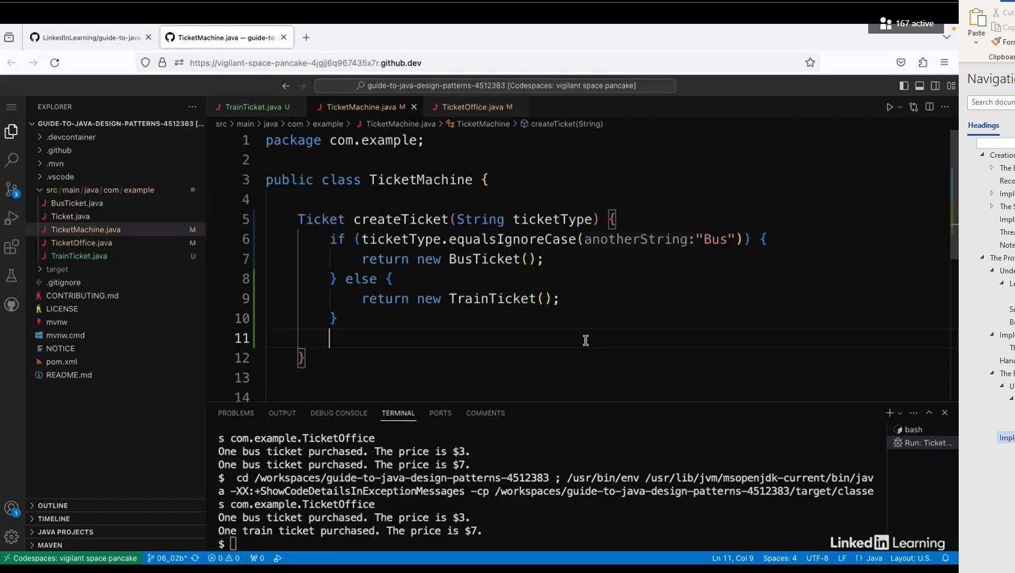

#### Improve the Factory Method pattern with functional programming.

Begin with code below:

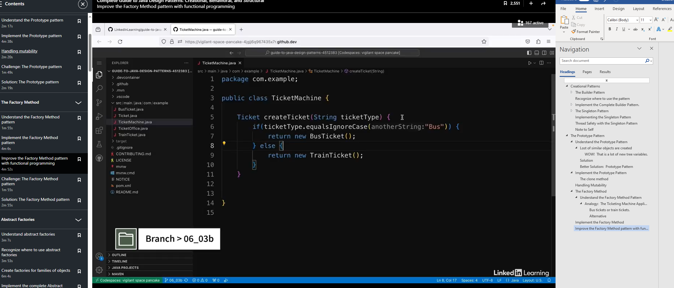

If you look at the code above, then you will need to add more code to the createTicket’s if/else clauses. This is not good.

Let’s use a HashMap with a static initializer.

We will also pass in a Supplier via a lambda.

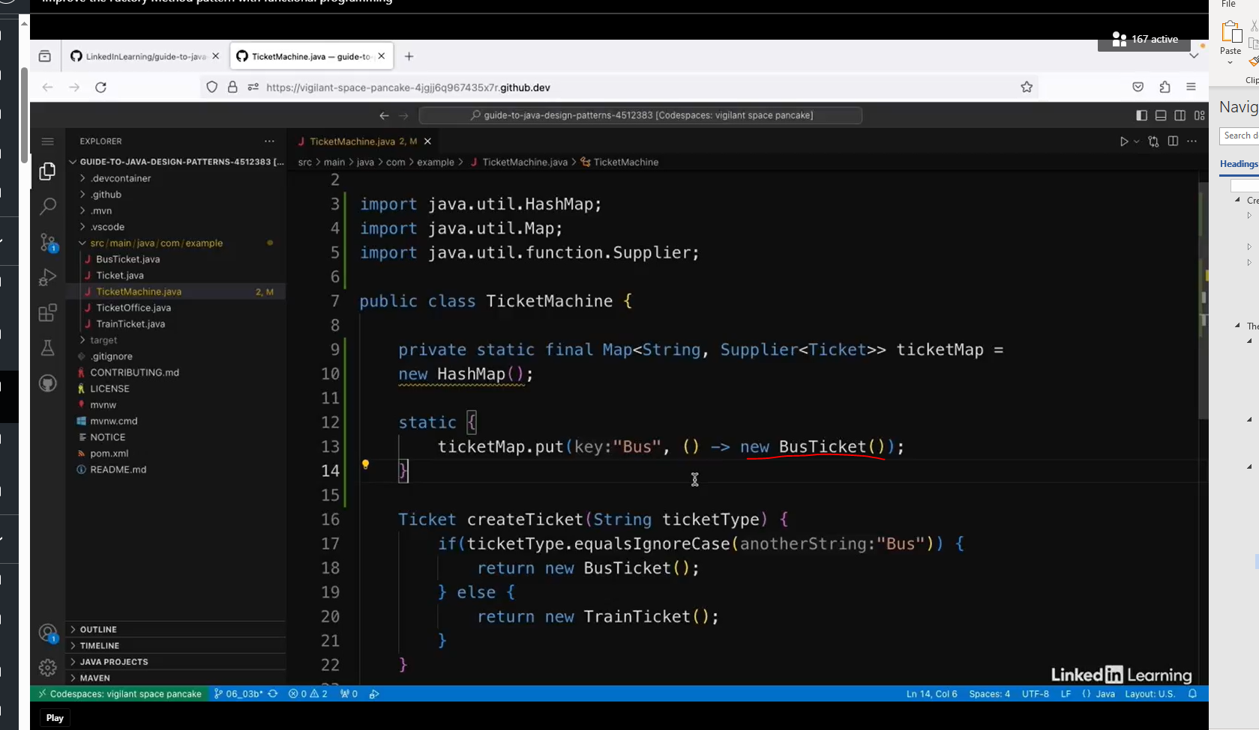

Better yet, let’s use method references. So this is shorthand for saying create a new BusTicket object.

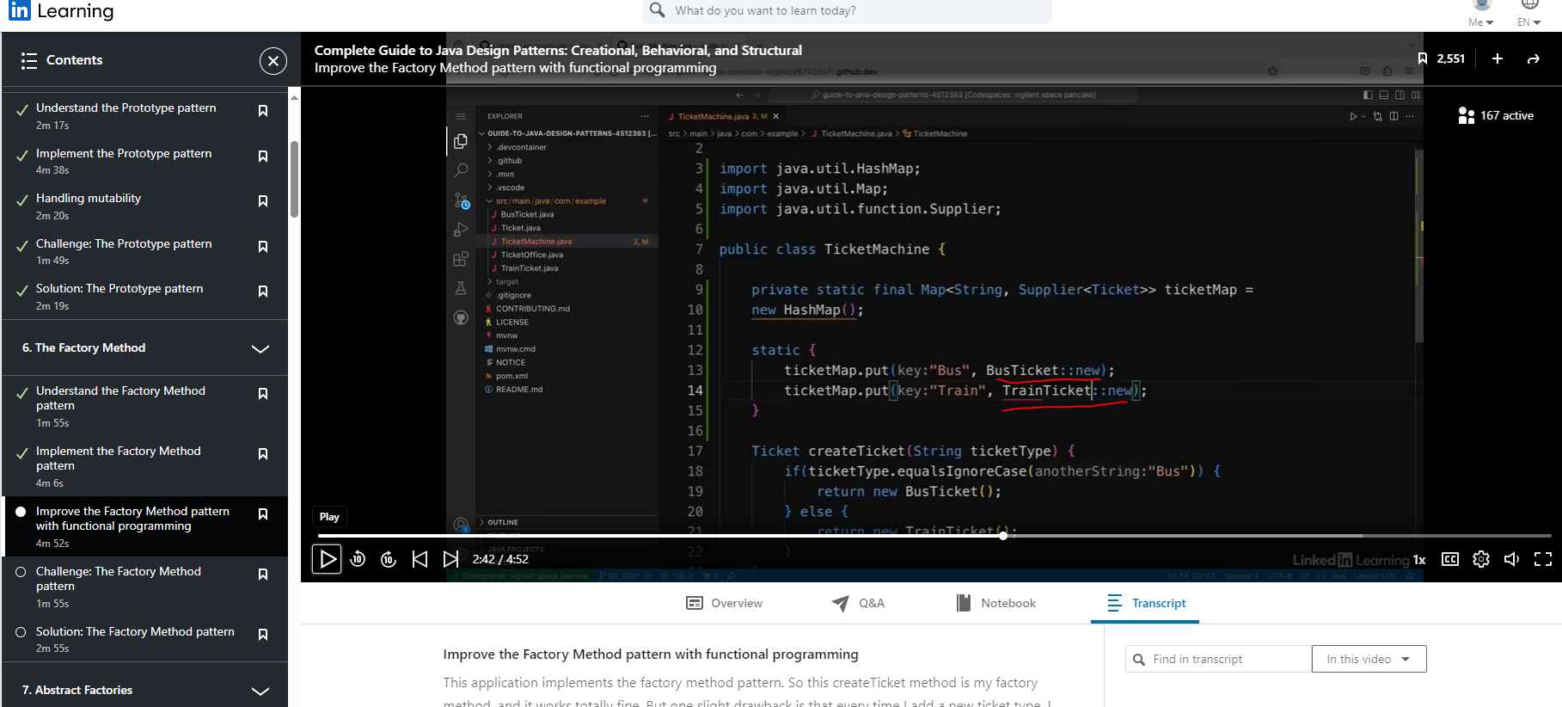

Now let’s refactor the createTicket method. Get rid of the if/else clause.

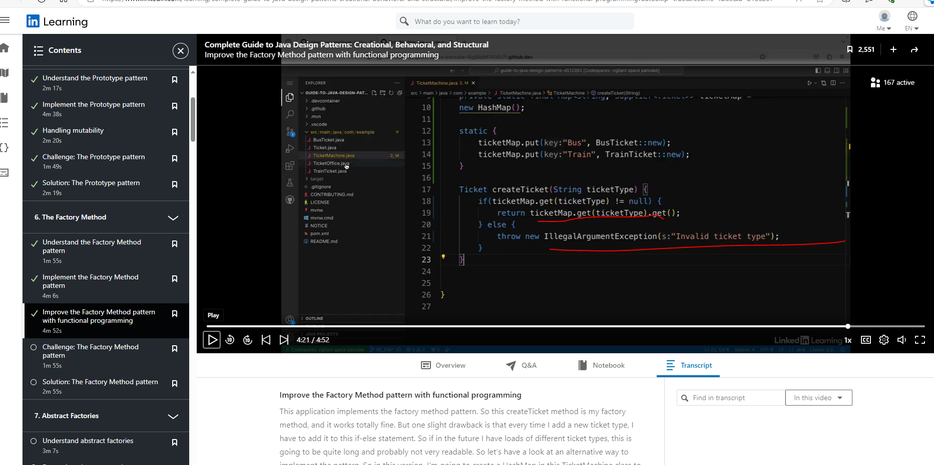

Code above is much better, but I wonder if we can improve it even further by using Optional.

### Abstract Factories

#### Understand Abstract Factories

##### Handling groups of related classes.



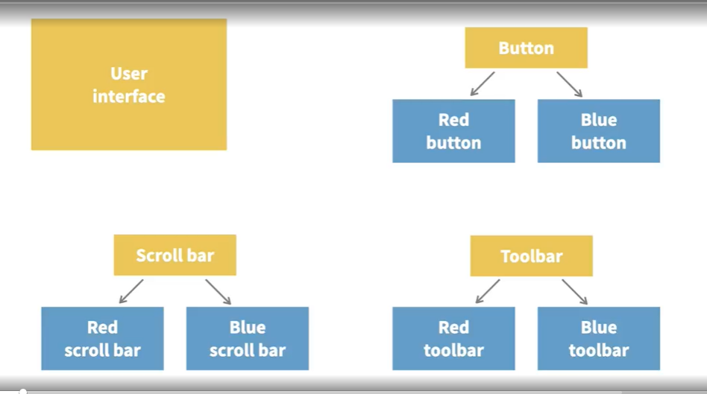

The user interface should be able to return the right objects to create the right color scheme. If the client wants a blue application, it should return a blue button, a blue toolbar, a blue scrollbar, and so on.

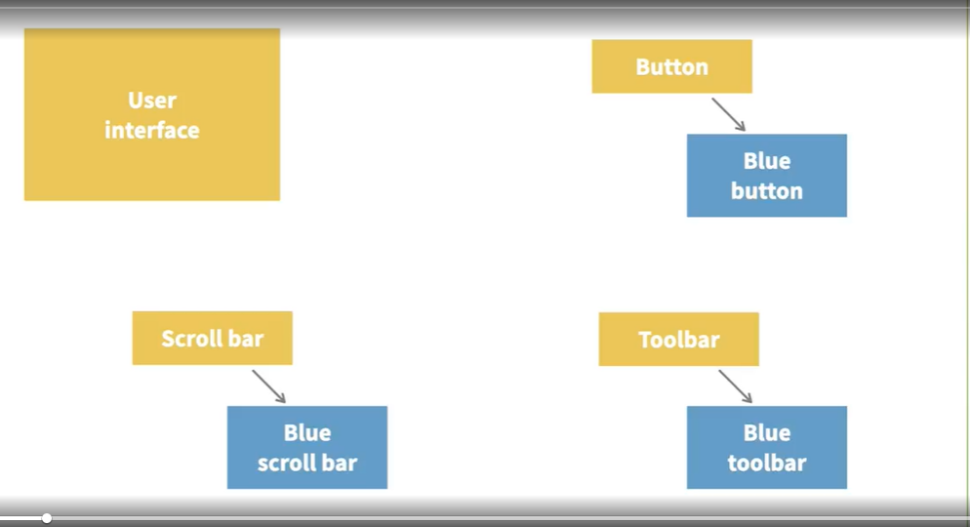

###### Requirements/Constraints

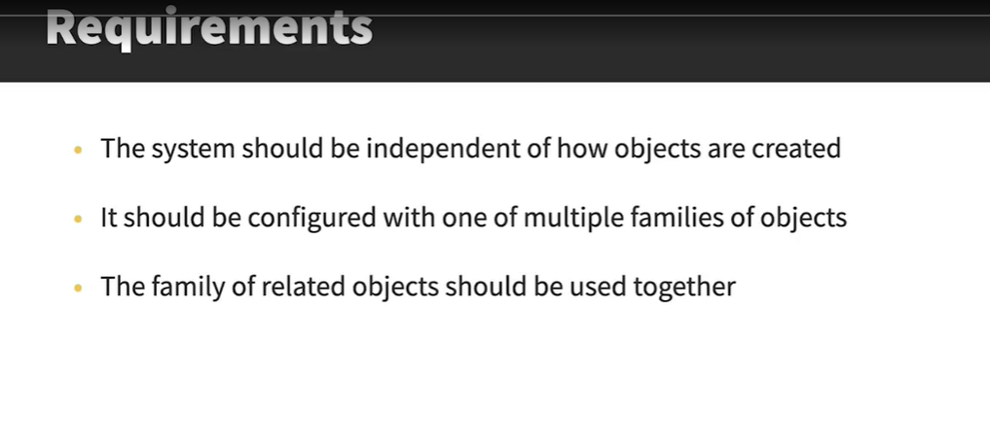

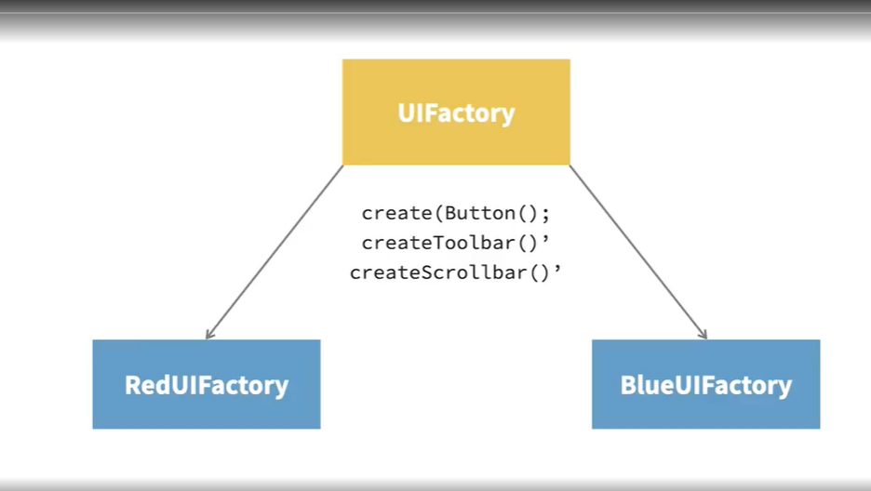

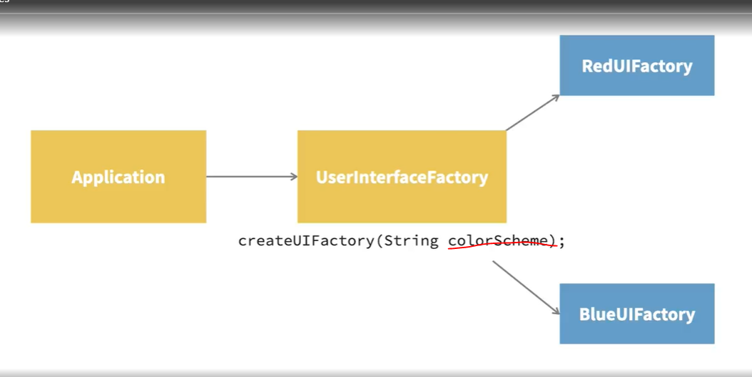

So if the application passes in red, it will use the red UI factory, and if it passes in blue, it will use the blue UI factory. So this pattern is essentially a factory of factories.

#### Drawback

Complex Class Hierarchy

#### Benefits

Concrete classes are isolated from the client.

Each section is easy to test.

As you can see, one drawback is that there are a lot of classes in this pattern implementation which can make it a bit hard to keep track of. And each time I add a new color or a new UI element, there are lots of new classes to create.

However, the positive is, this means that the application itself doesn't need to know anything about all the different families and how the objects are created behind the scenes. It only needs to know about the user interface factory and everything else is hidden, and in turn, the user interface factory only needs to know about its concrete implementations. They handle the actual creation of the UI objects like buttons and so on. So a lot of the complexity is abstracted away. Another nice thing about this pattern is that each part of it is quite easy to unit test. Concrete classes are injected as dependencies, which means they can easily be mocked.

### Recognize When to use Abstract Factories

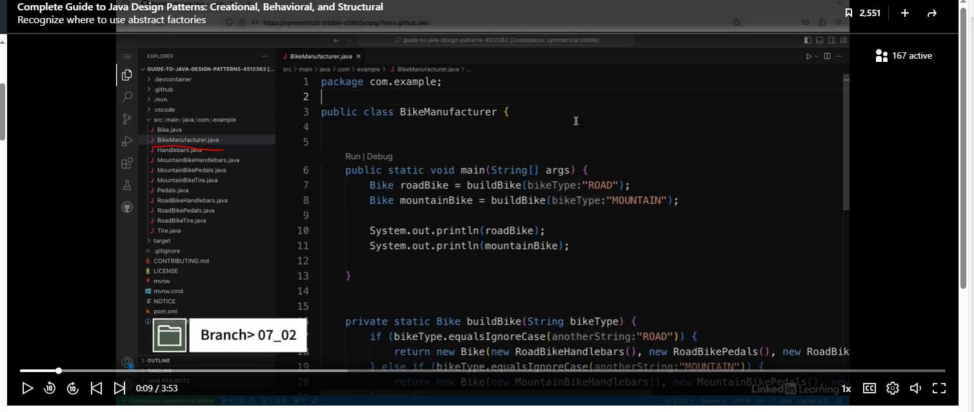

Let’s look at the Bike class.

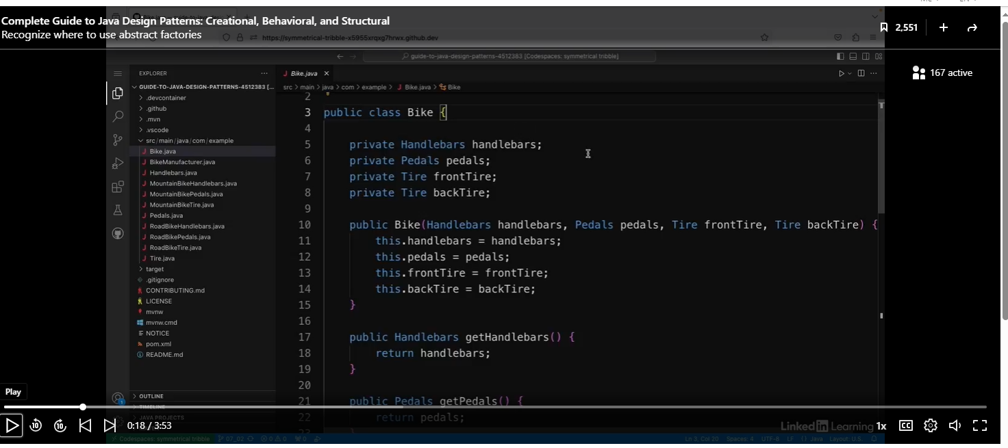

Each of these fields is an interface.

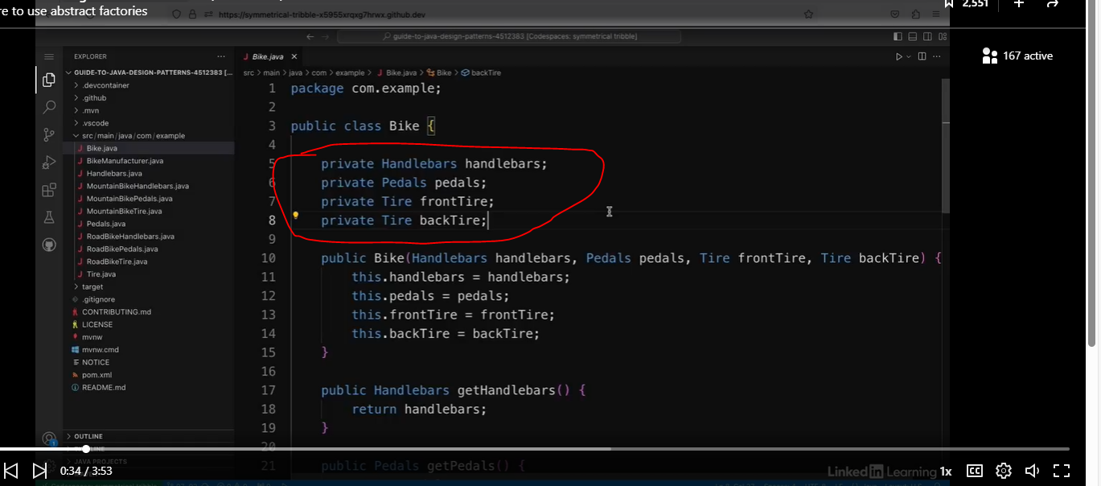

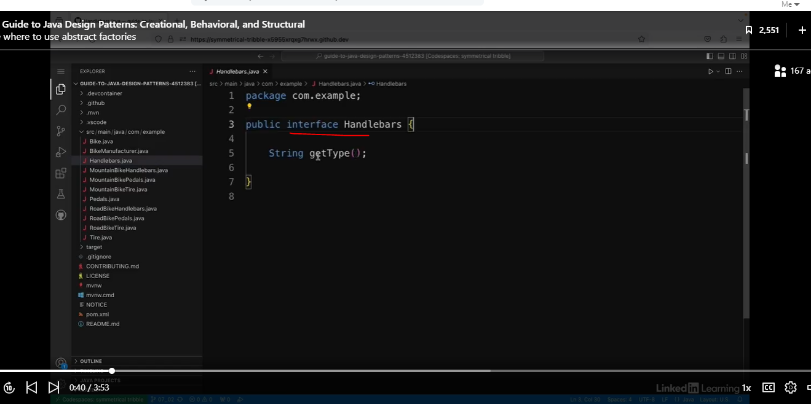

See implementation of the interface.

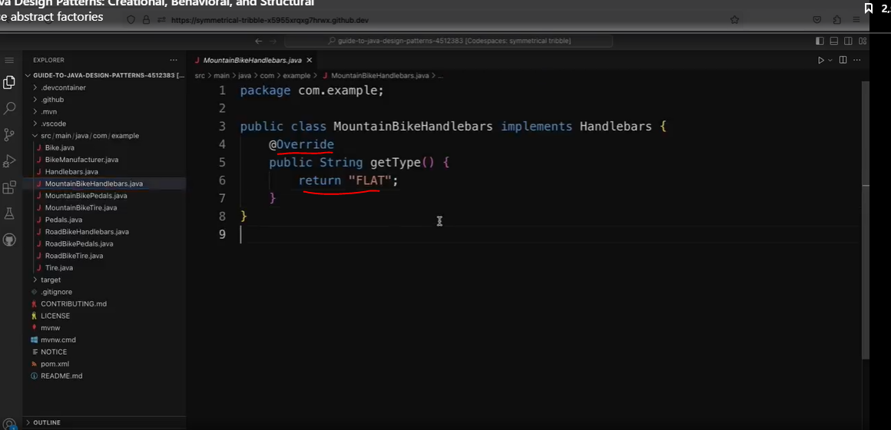

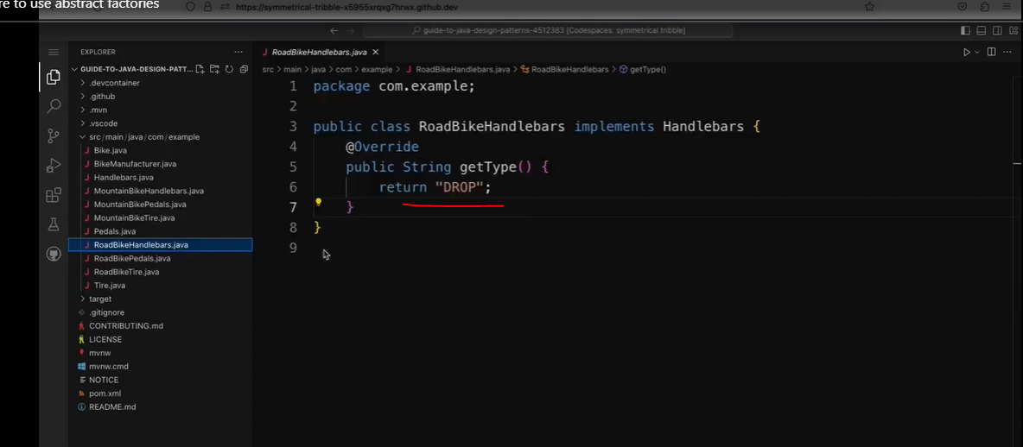

So if you find that you have a structure similar to this, where you have an object with lots of fields that can be of different types, that might be a sign that your application might benefit from using the abstract builder pattern.

See code below:

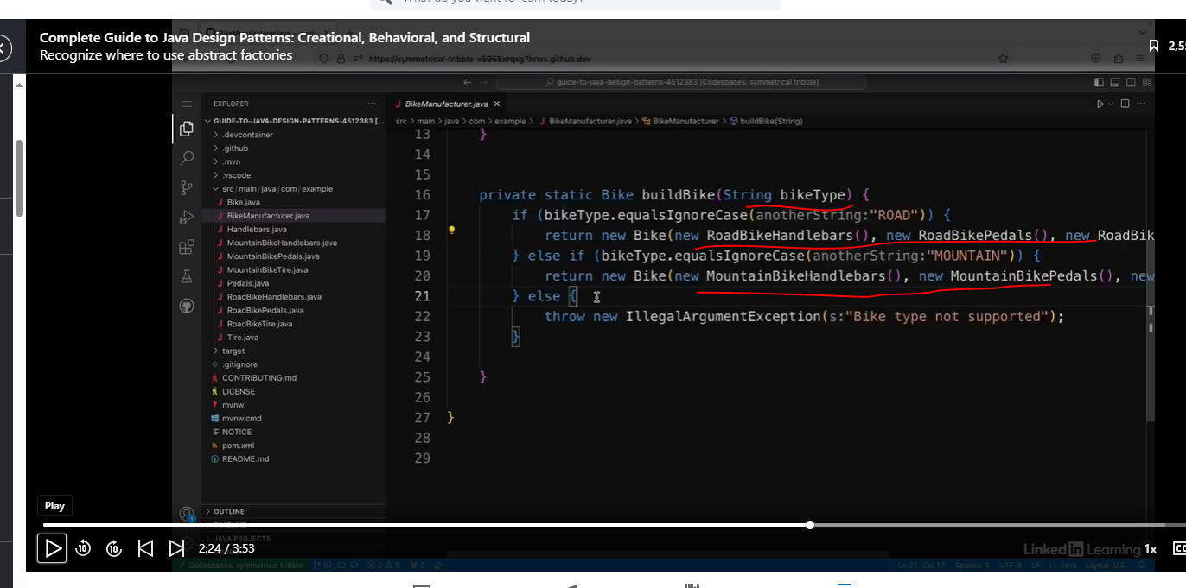

See client code.

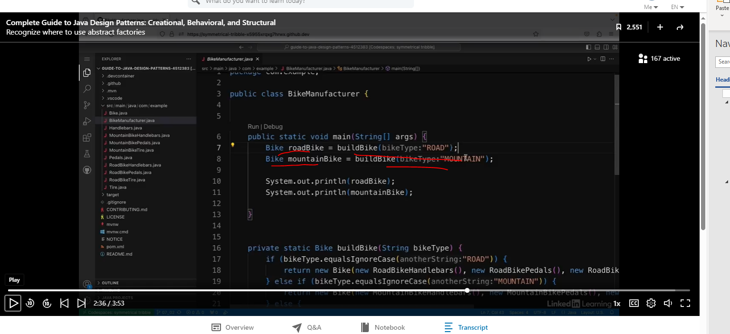

The design above works, but it is tightly coupled. If I wanted to add a different type of bike type, then I would have to update the buildBike method.

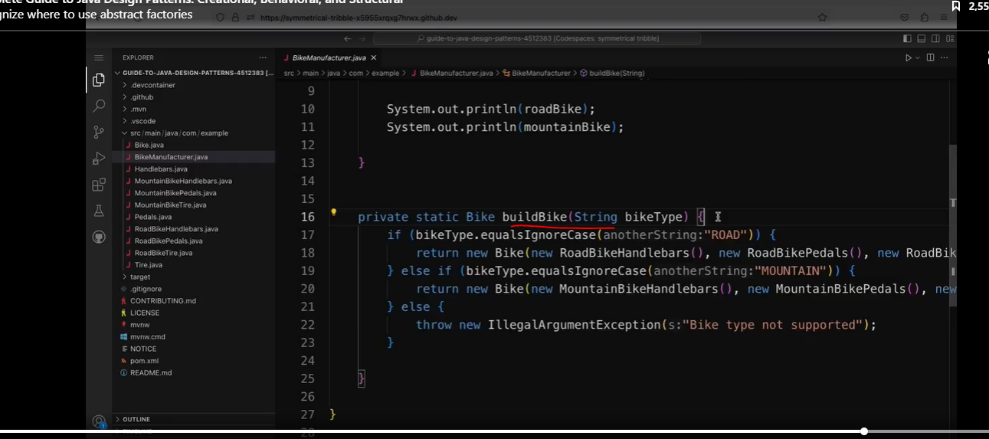

### Create Factories for Families of Objects

See code below:

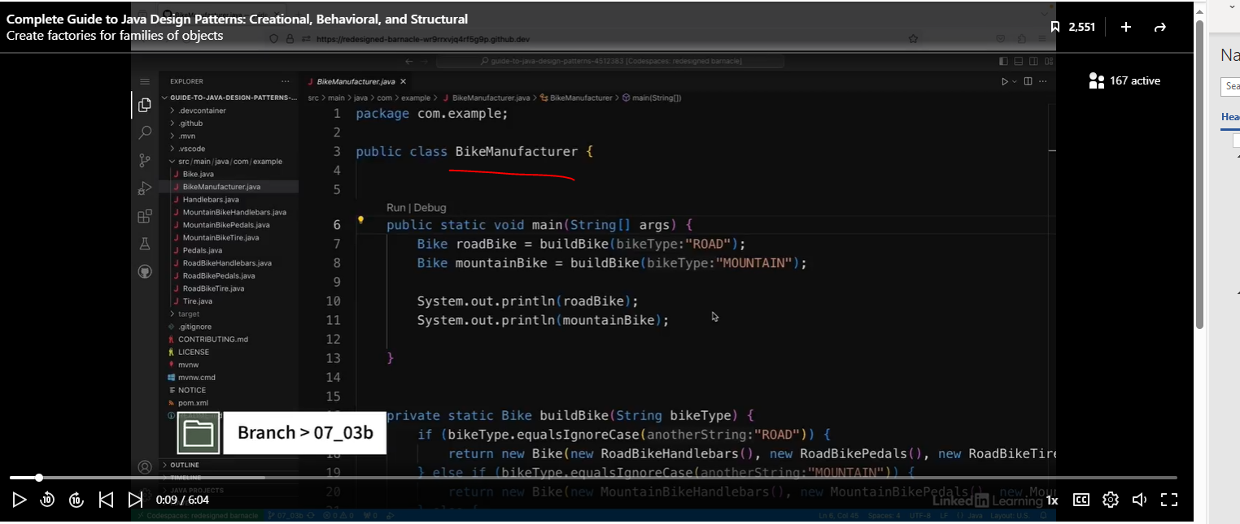

This is an example of an application that has families of objects. So it's an application that creates bikes from different bike parts. And there's a family of bike parts that go together. But one way I can improve this application is by using factories to create bikes with all the right bike parts together. The idea is to have a different factory for each different type of bike.

Let’s look at BikeFactory

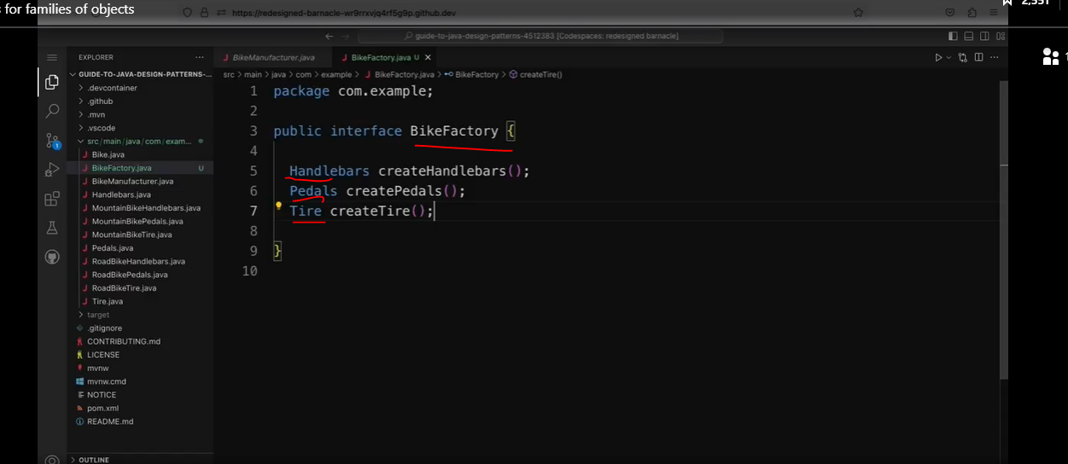

Now let’s implement the interface above.

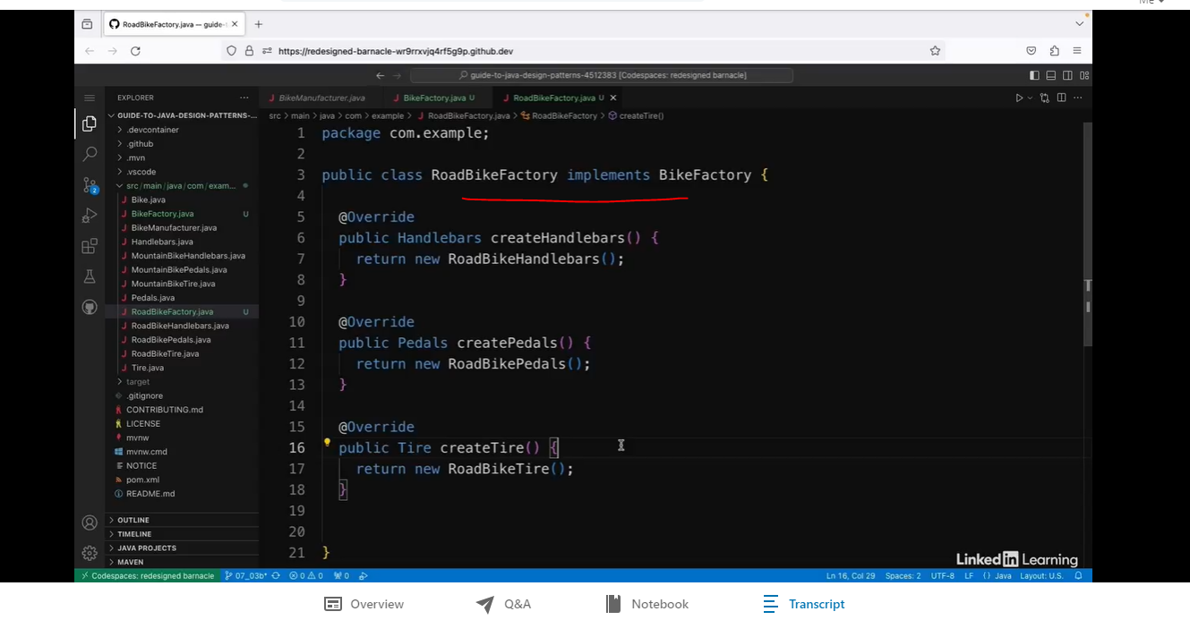

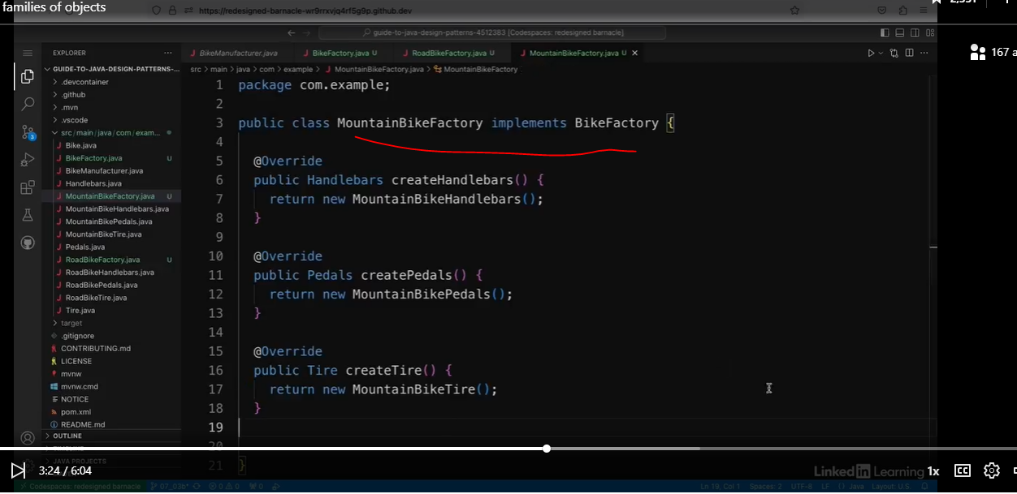

We are going to refactor the code below:

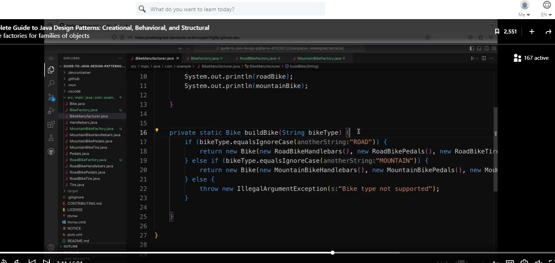

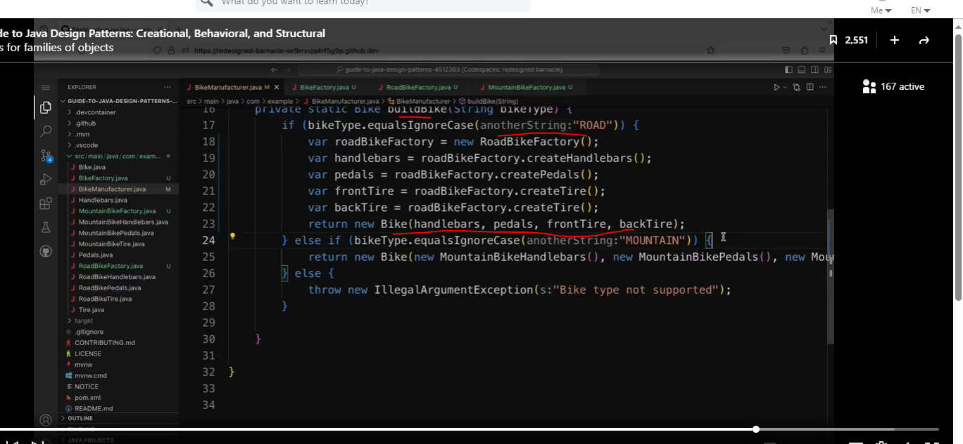

Code below has two different factories.

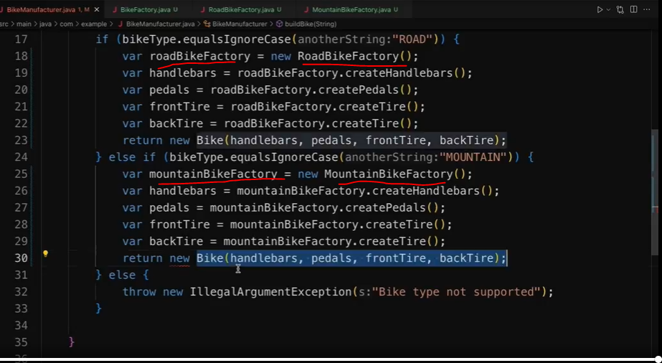

So this is a good step forward. This BikeManufacturer class no longer needs to know how different types of handlebars and pedals and so on are created. However, I still have the issue that I need to copy and paste lots of boilerplate code for each of the different bike types. So to get the full benefits of the abstract factory pattern, I need to create a factory to encapsulate how the bike parts are put together. So there's still one more step to do, which I'll show you in the next video.

### Implement the Complete Abstract Factory Pattern

See code below:

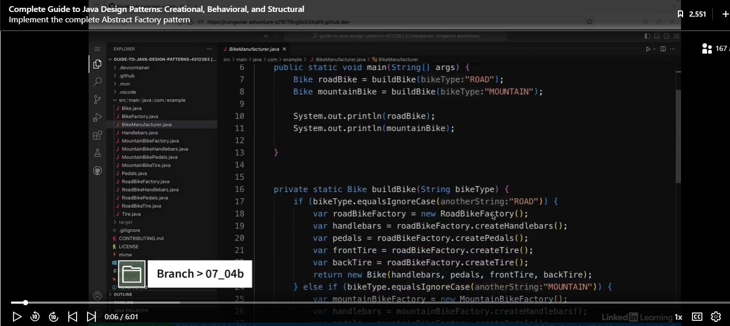

Yuck! We have a lot of boiler plate code.

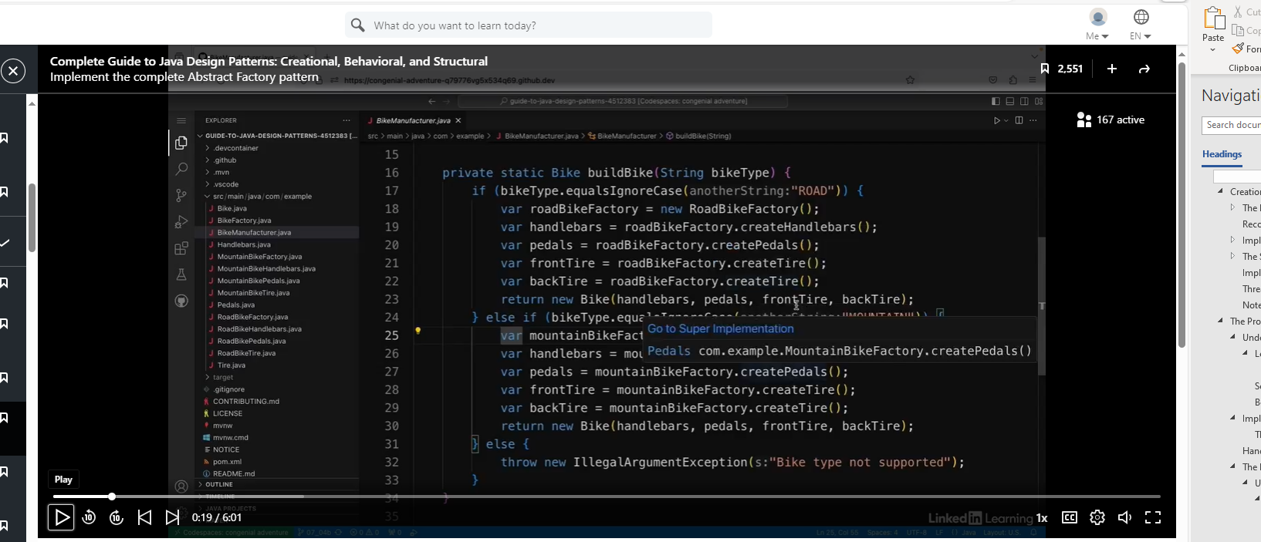

So what I'm going to do is I'm going to create another factory to handle that logic. So I'm going to create a new class, and I'm going to call this one FactoryMaker.

We will use the static map of Suppliers.

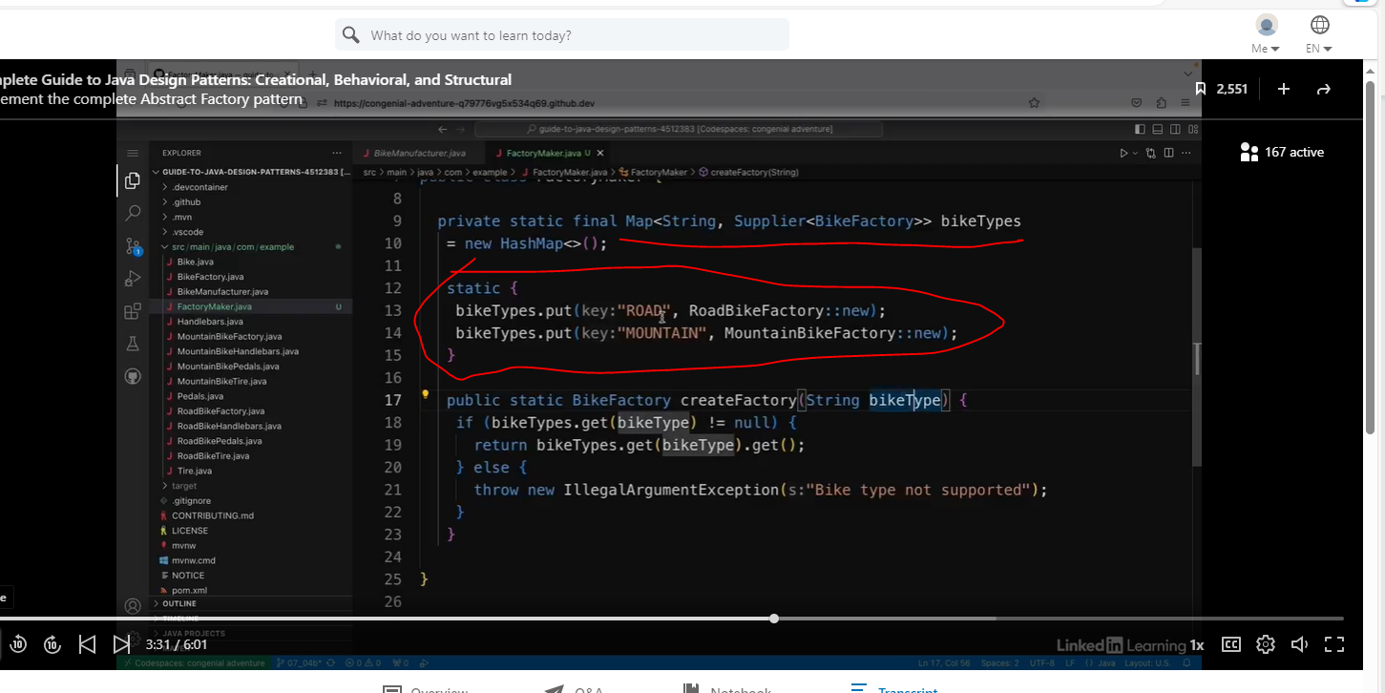

Now let’s simplify all of this boiler plate code below:

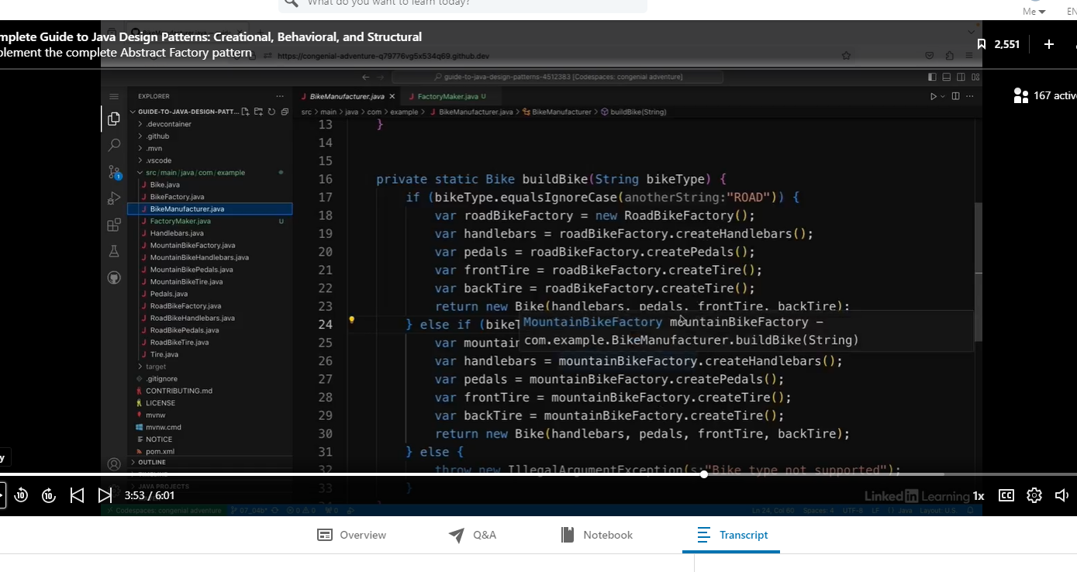

The code below is much cleaner. Easier to read and more flexible.

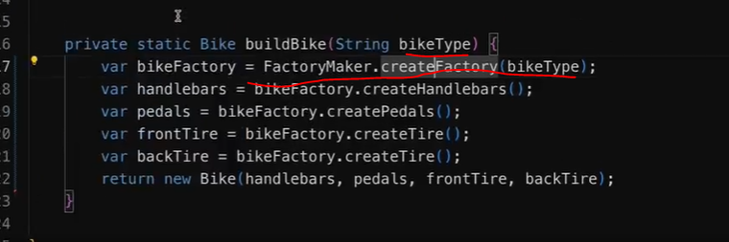

So this method is now much shorter and a bit more readable, but more importantly is actually much more flexible. So if I add a new bike type with all the different bike parts, I don't need to change the BikeManufacturer class at all. I don't need to change anything in this method, it's just really nicely decoupled. Instead, I would have to create a new factory for the new bike type and add that type to the Map in the FactoryMaker class. So in here, I would just add a new value to the Map inside this static block. So the client, which in this case is the bike manufacturer, doesn't need to know anything about how the different types of bike are created.